DEPARTMENT WORKSHOPS AND GUEST LECTURES
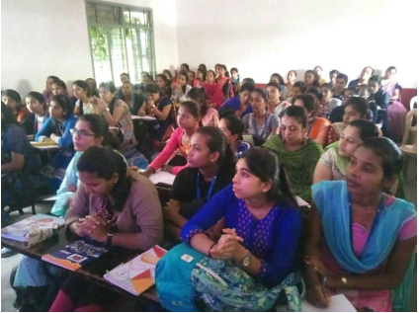
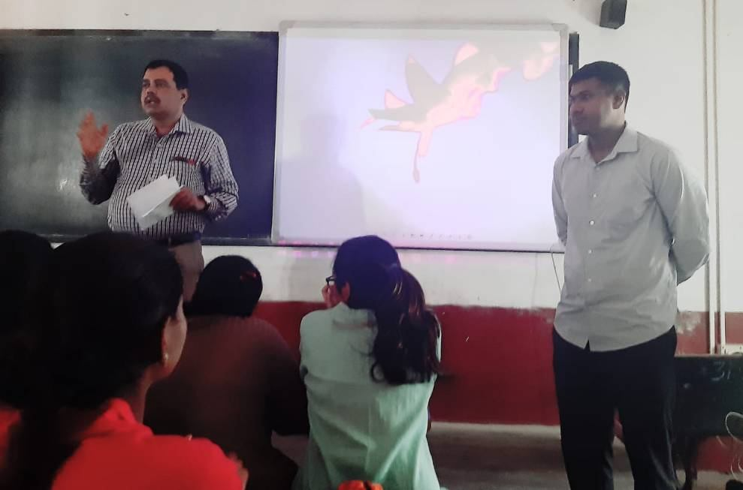

An orientation program on the topic entitled “How to do research work”

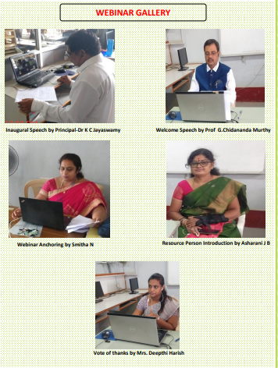

One Day International Webinar was organized by Department of Botany and Microbiology in association with IQAC on 10th September 2020 at 12.30pm. The Objective of talk on the Topic “THE TRANSFORMATION OF

HEALTHCARE THROUGH ARTIFICIAL INTELLEGENCE”

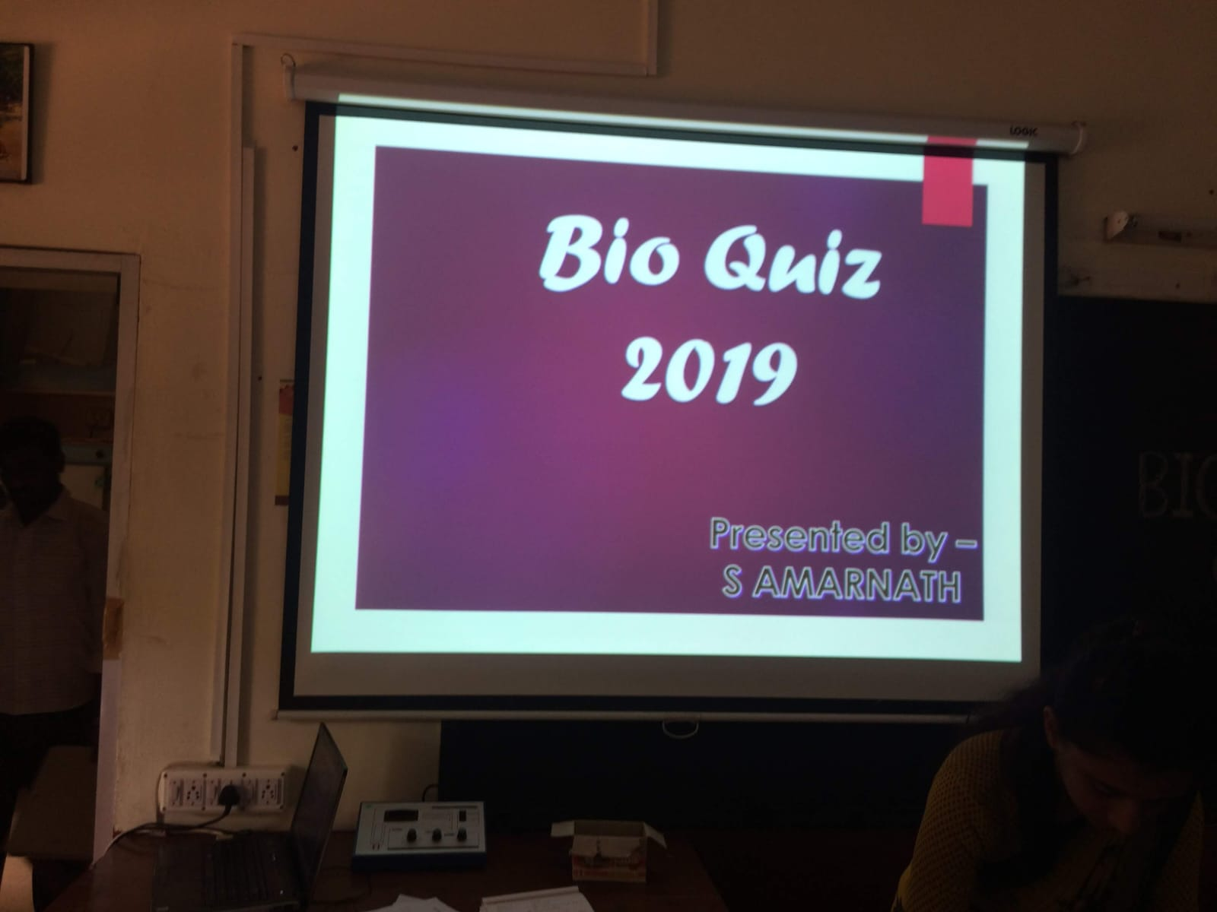

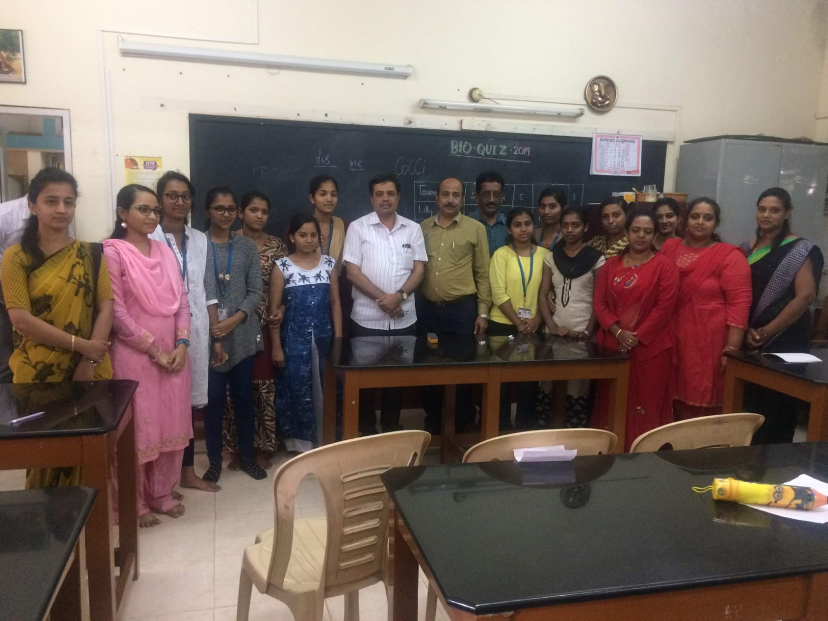

Bio quiz 2019

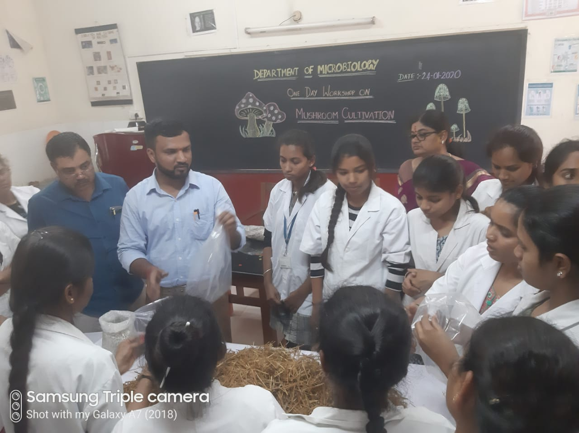

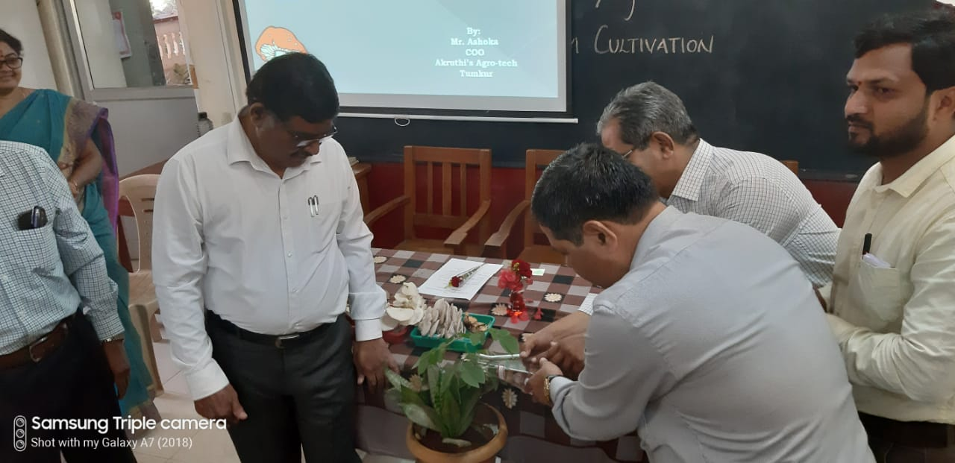

One day workshop on Mushroom cultivation on 24-01-2020

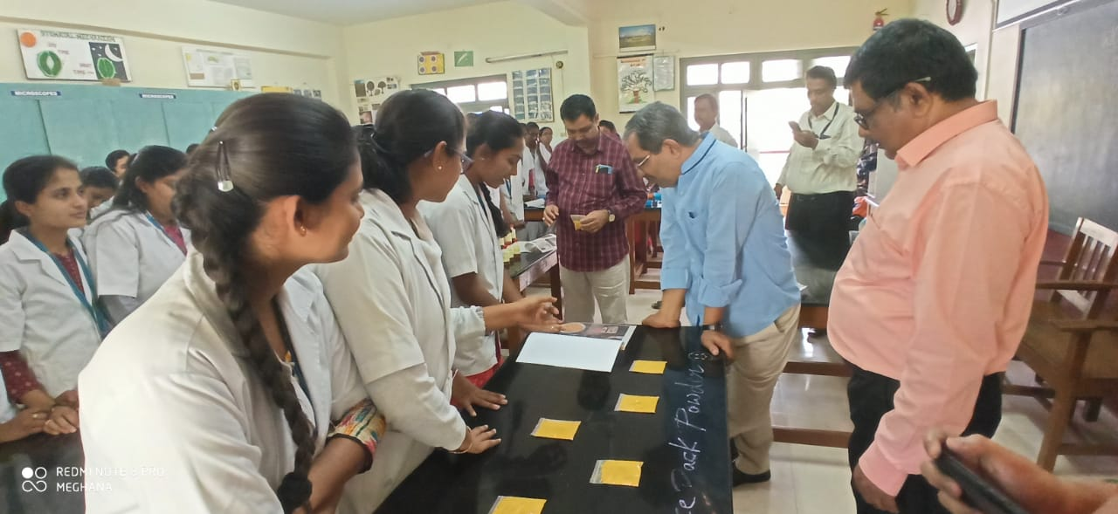

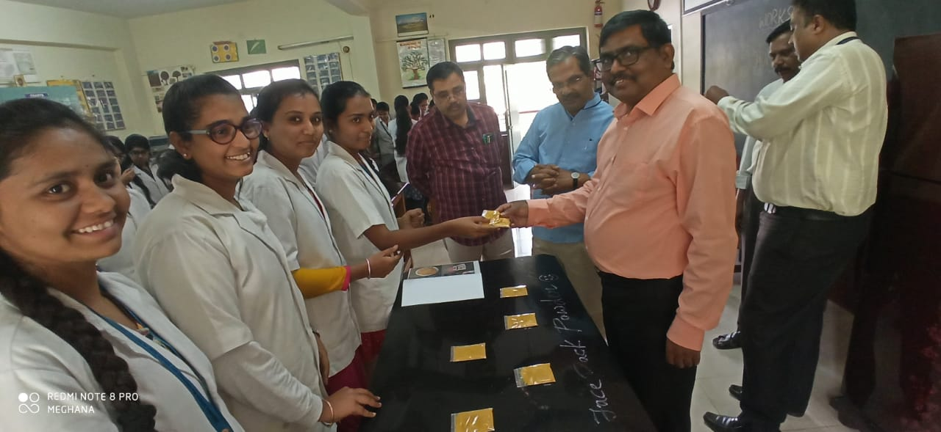

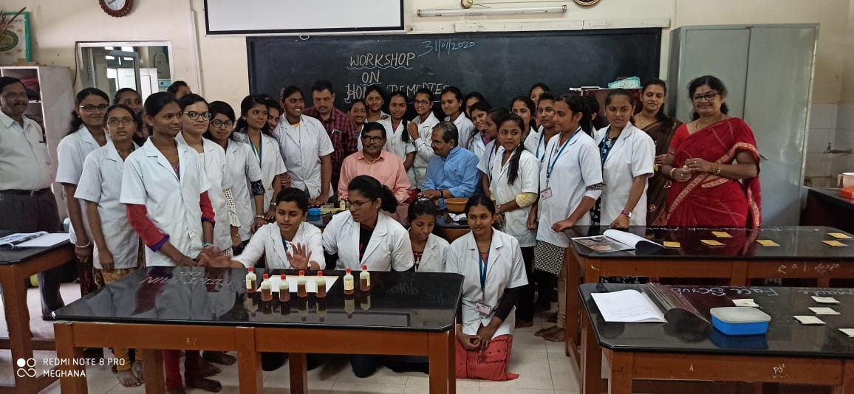

Herbal medicines preparation by the students of Botany Department on 31-01-2020

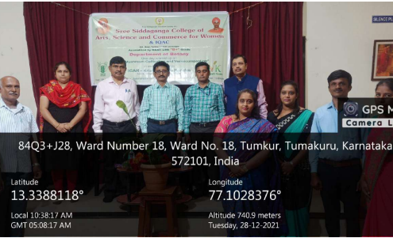
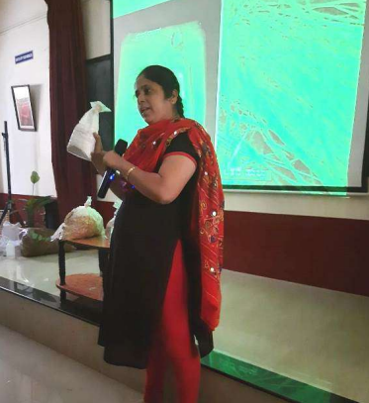

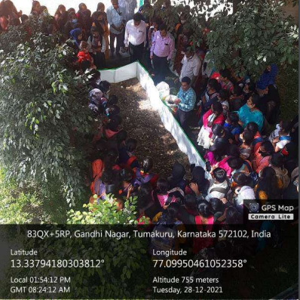

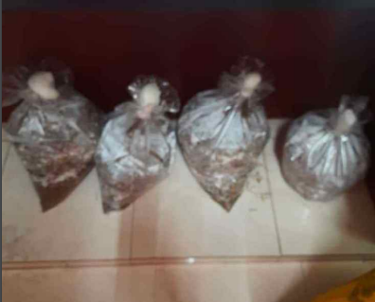

Department of Botany organized one day workshop on ‘Mushroom cultivation and Vermicomposting’ on 28-12-2021

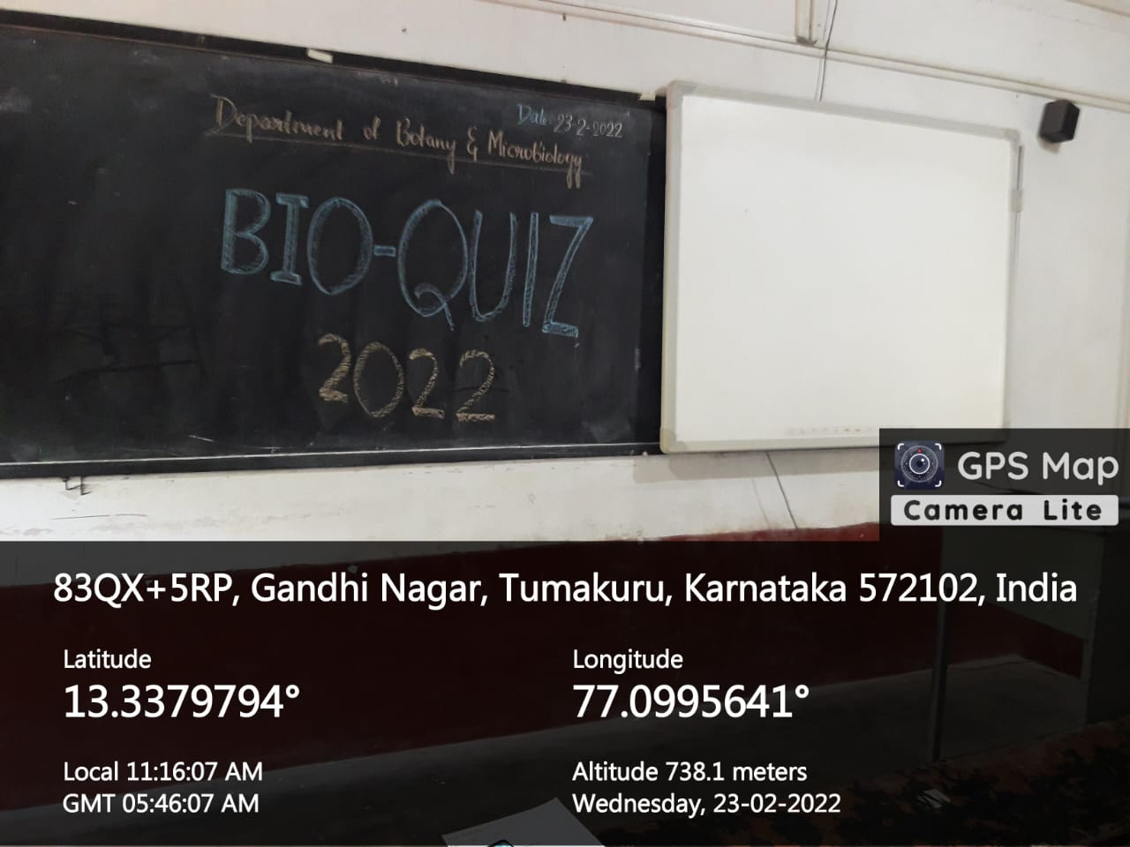

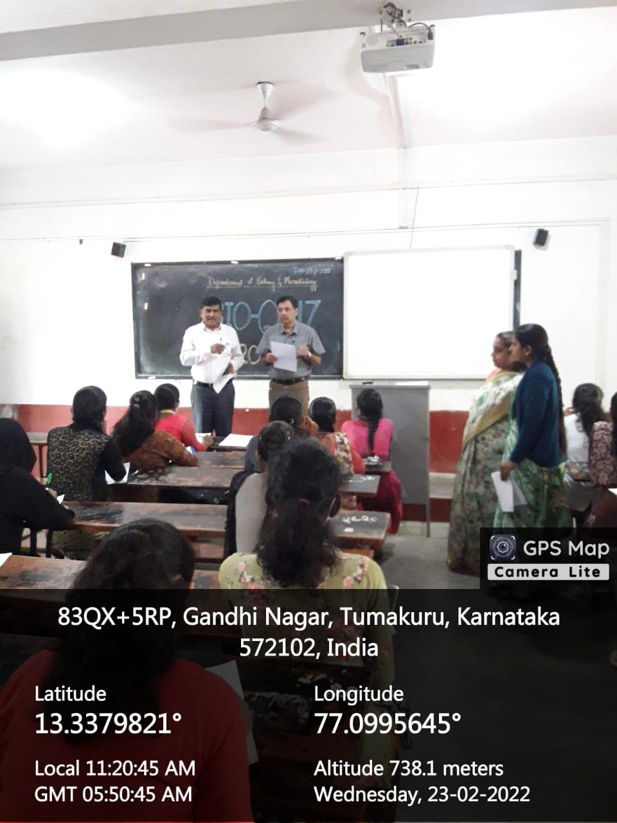

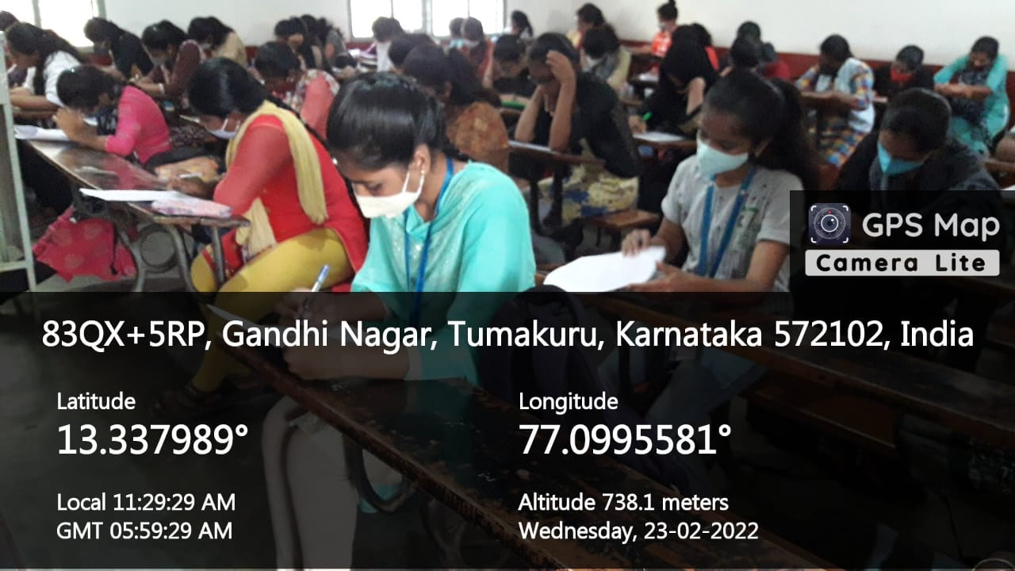

Bio Quiz organized by the department on 23-02-2022

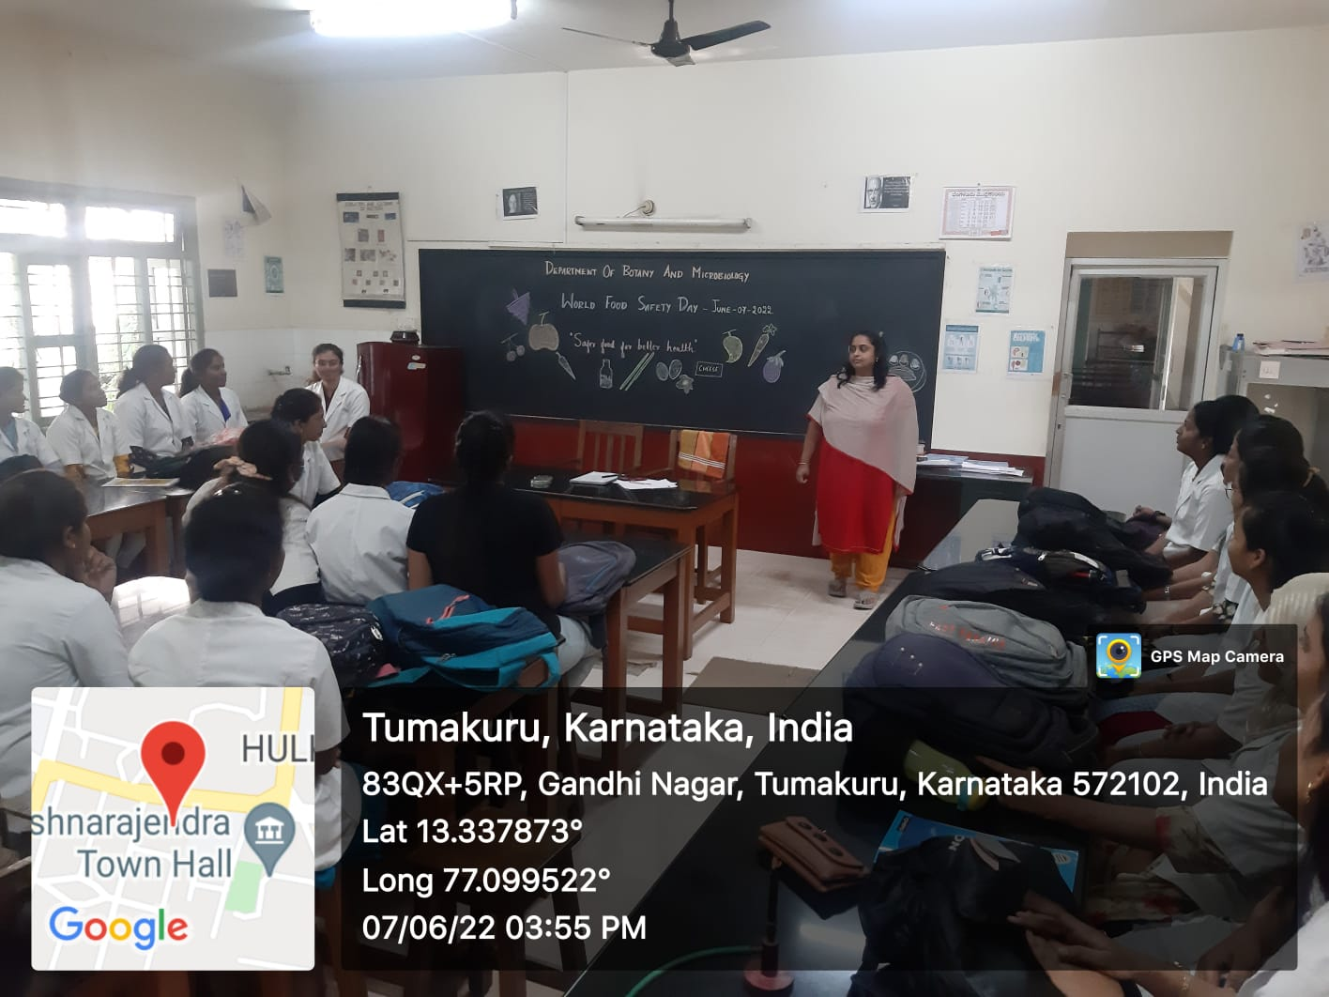

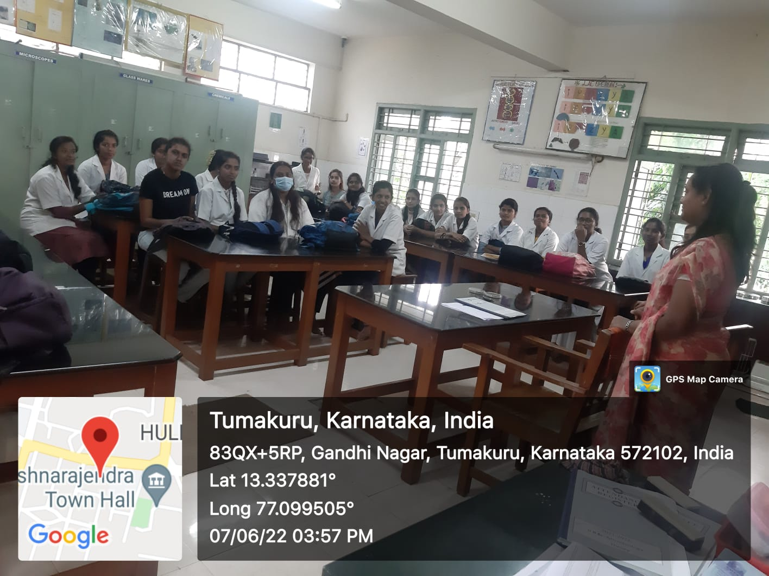

The Department of Botany and Microbiology organized Food Safety Day celebration on 07-06-2022

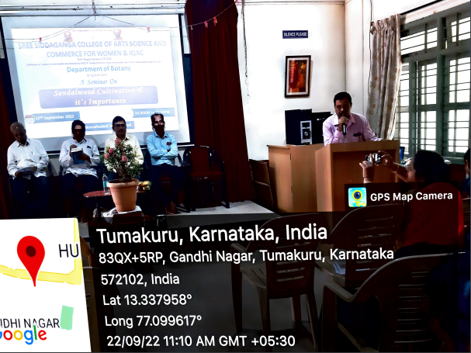

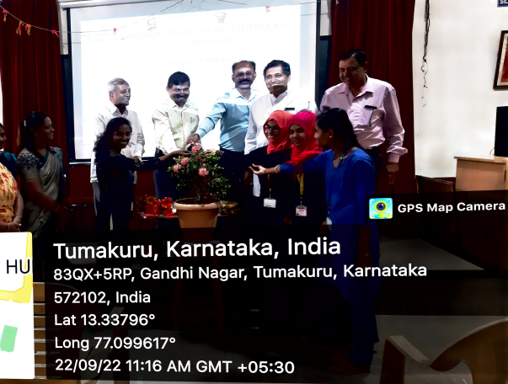

Guest lecture on ‘Sandalwood cultivation and its importance’ on 22-09-2022

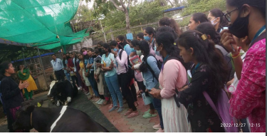
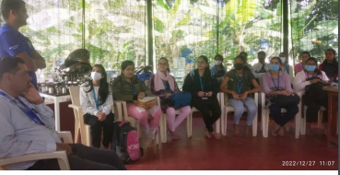
Akshayakalpa organic farm visit on 27/12/2022

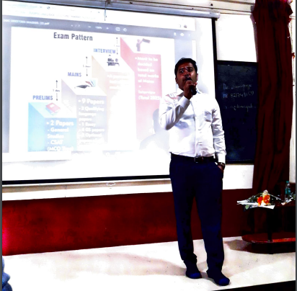

One day workshop session on ‘UPSC competitive examination’ on 05-12-2022

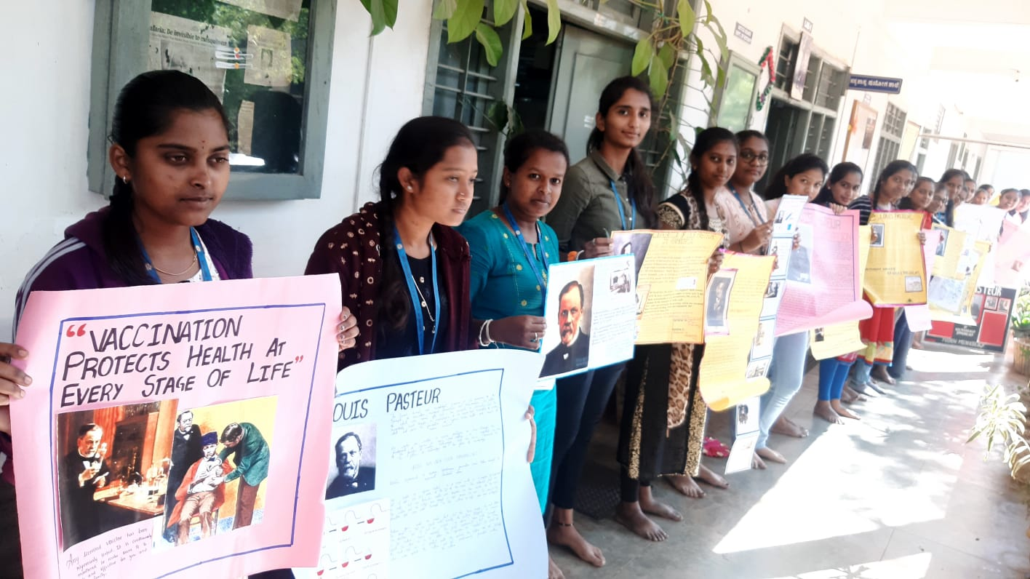
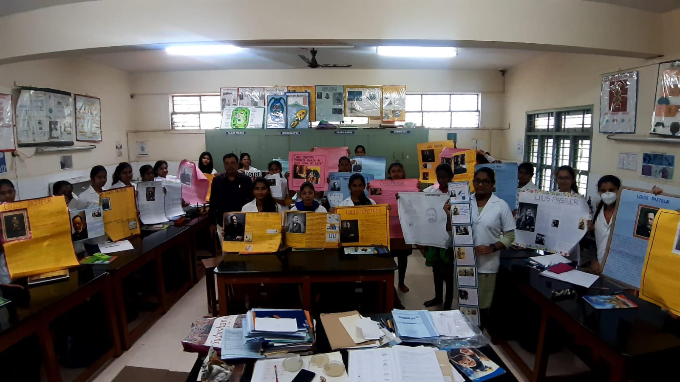

Louis pasteur Birthday celebration by making poster presentation on his contribution on 27-12-2022

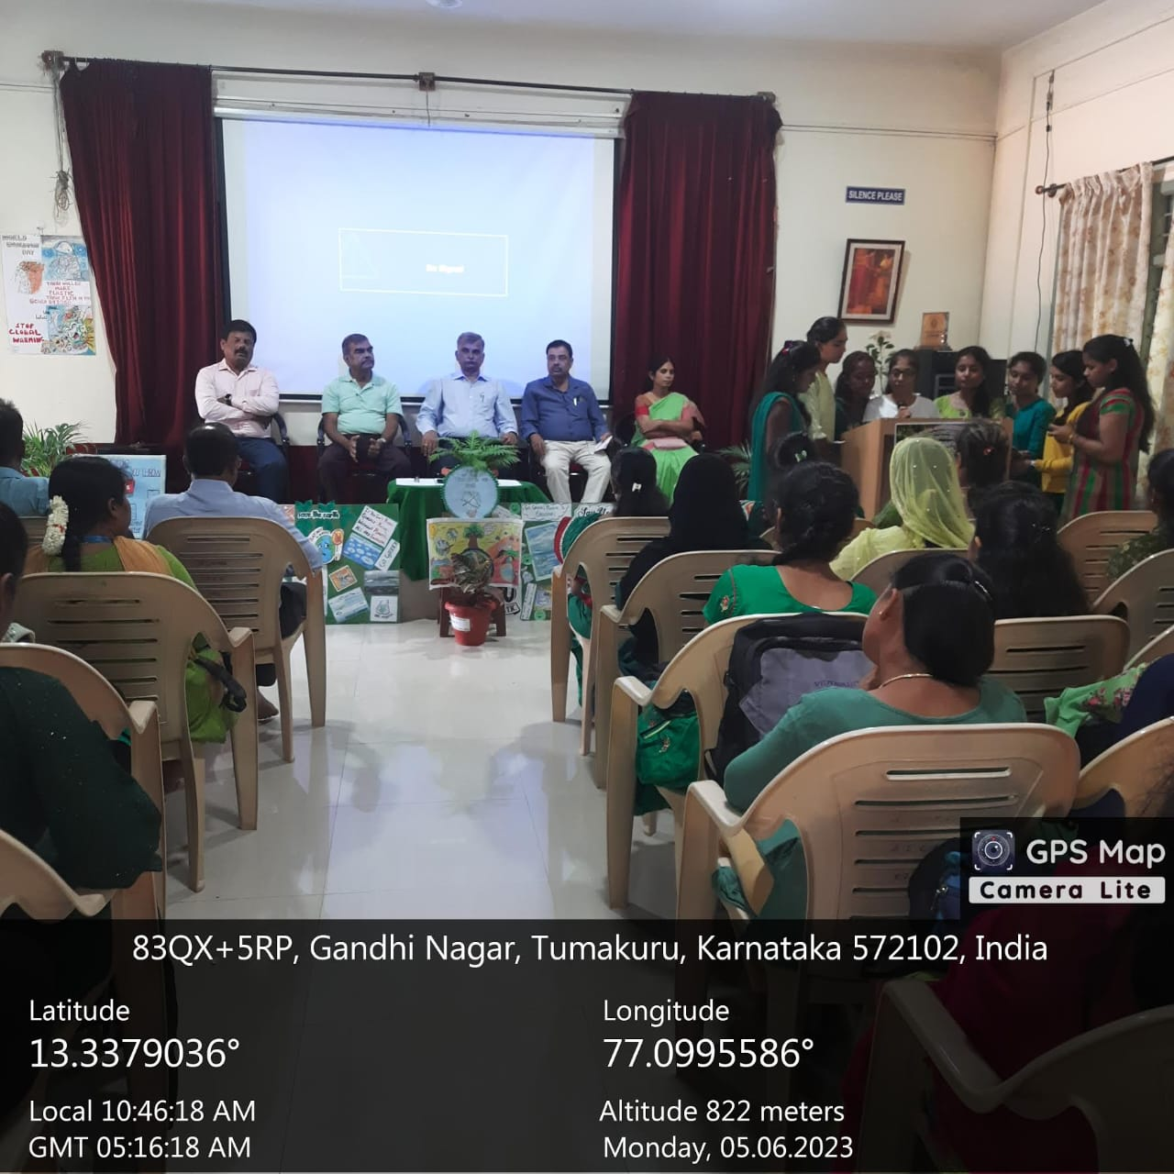

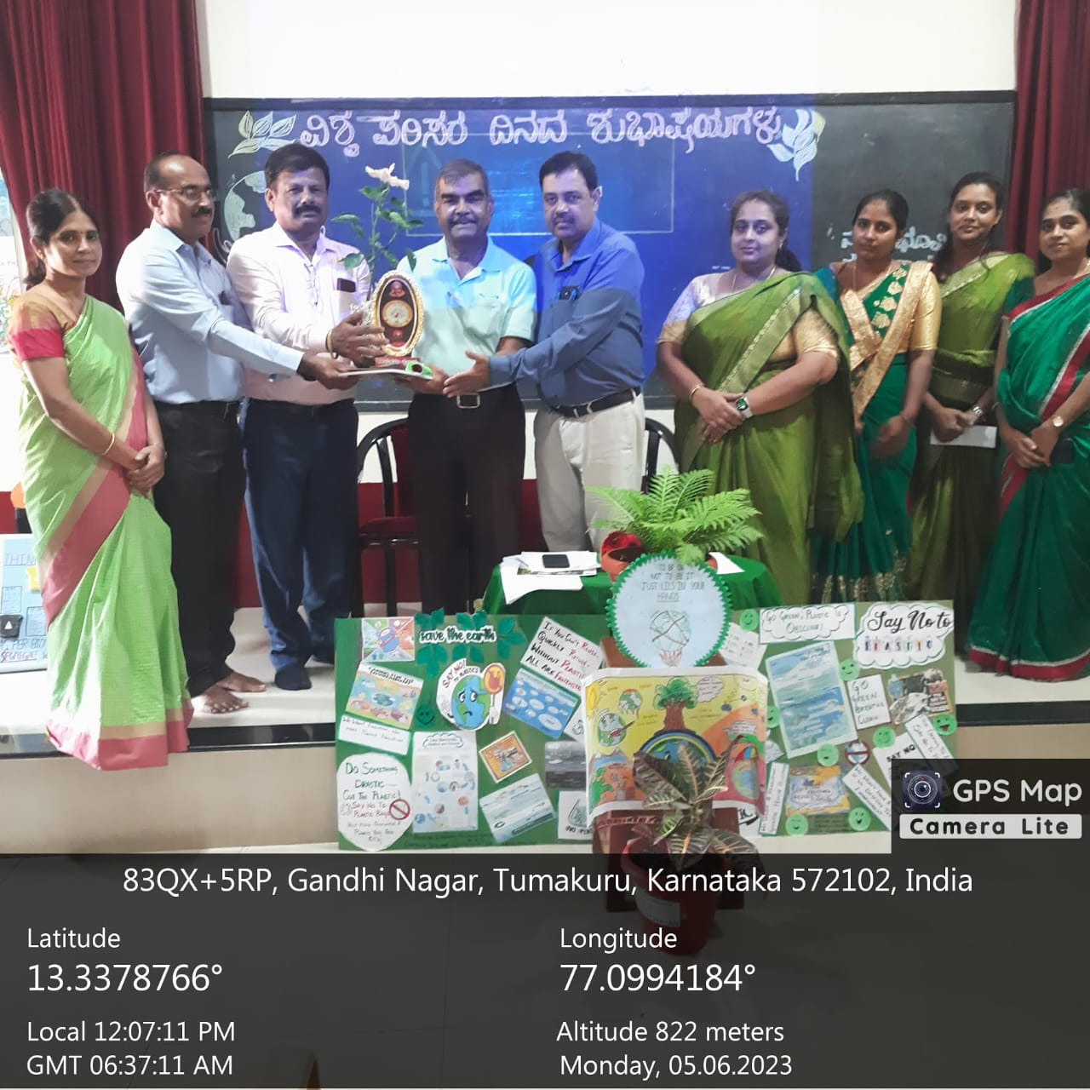

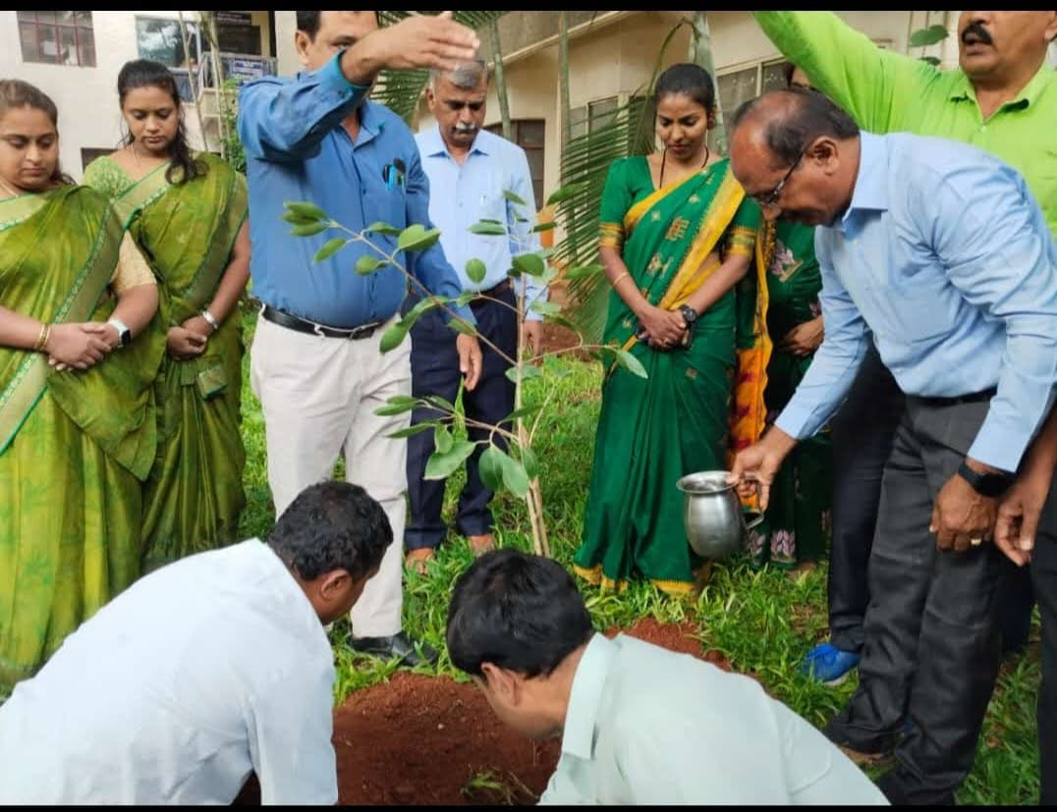

Environment day celebration - 2023

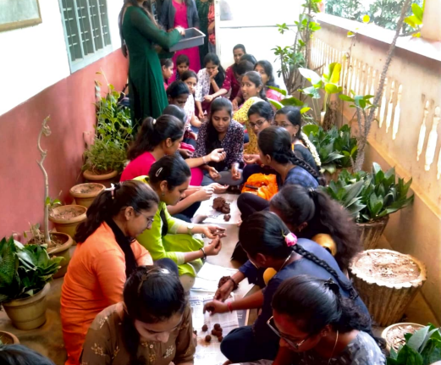
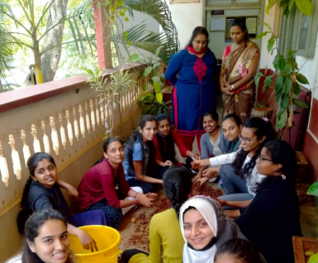
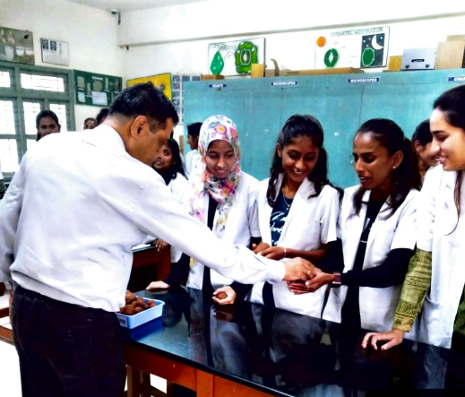

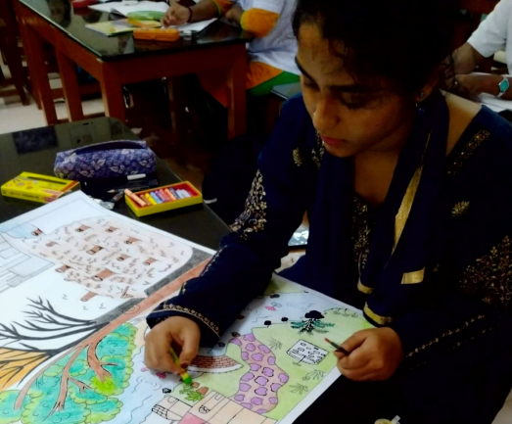

The Department of Botany and Microbiology conducted seed ball making and poster making activities on 04-06-2023 for Environment Day.

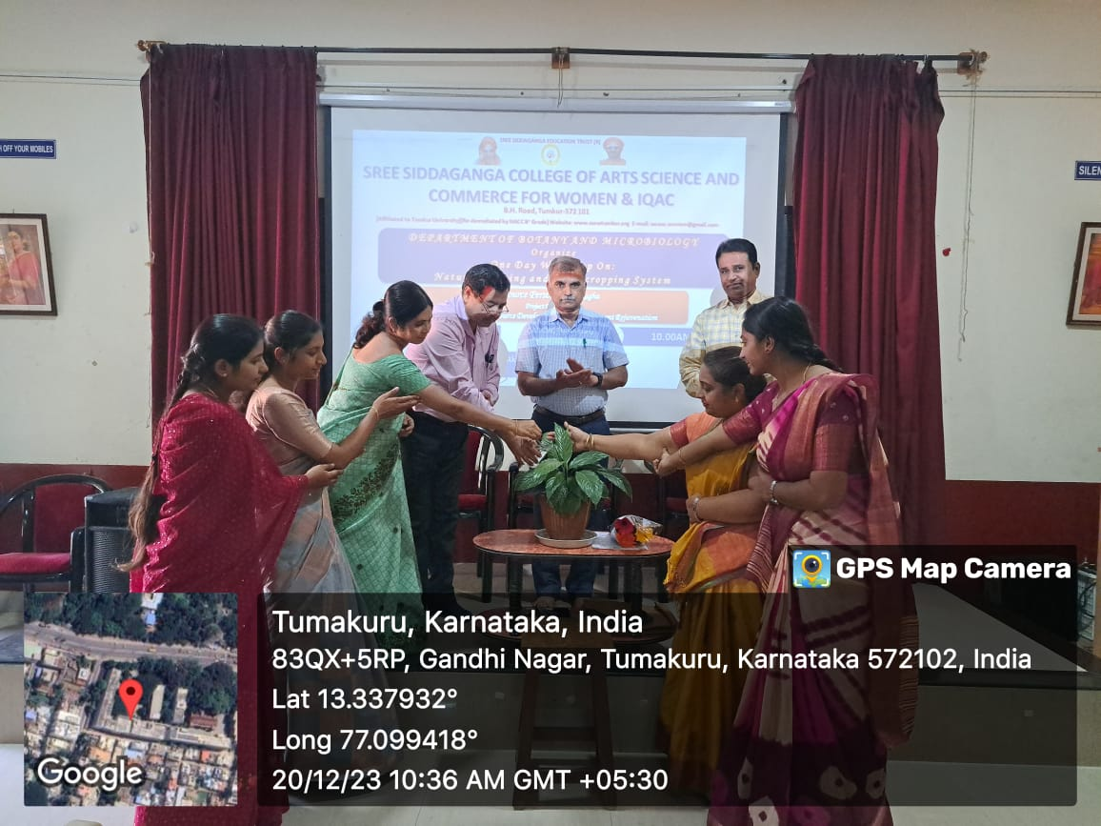

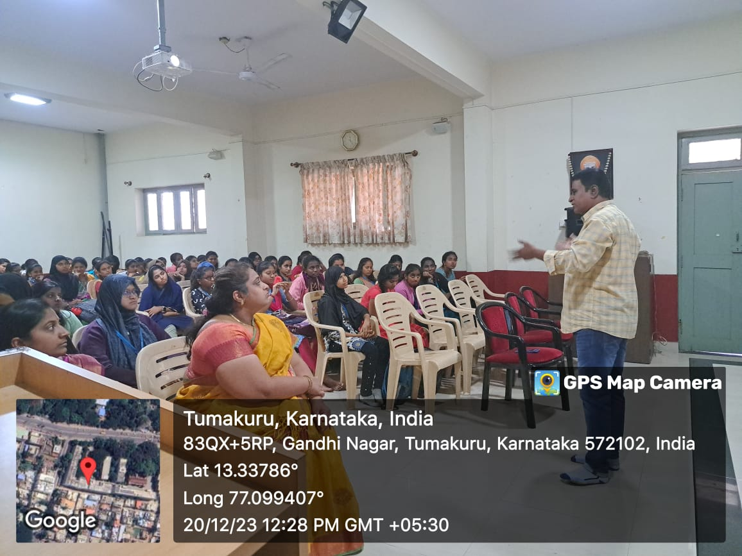

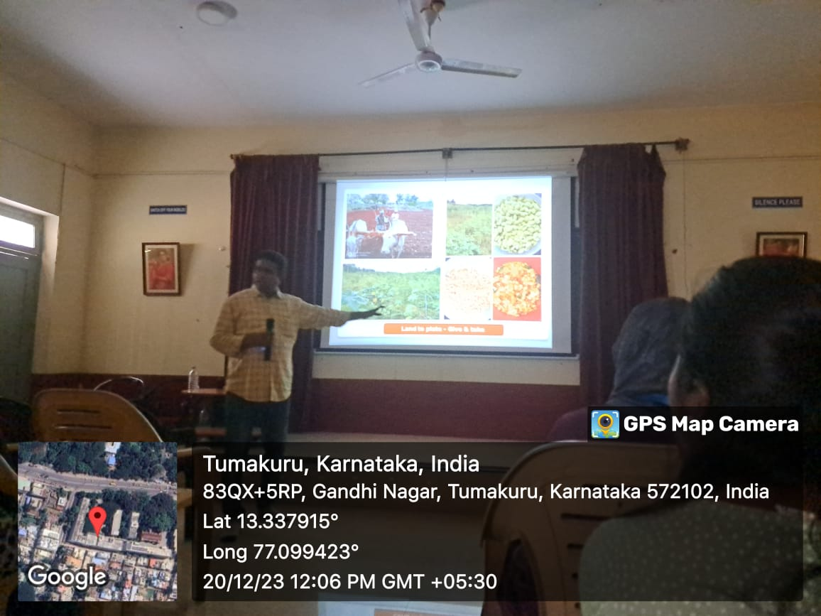

One day workshop on’ Natural farming and multicropping system’ on 20-12-2023

FIELD AND INDUSTRIAL VISITS

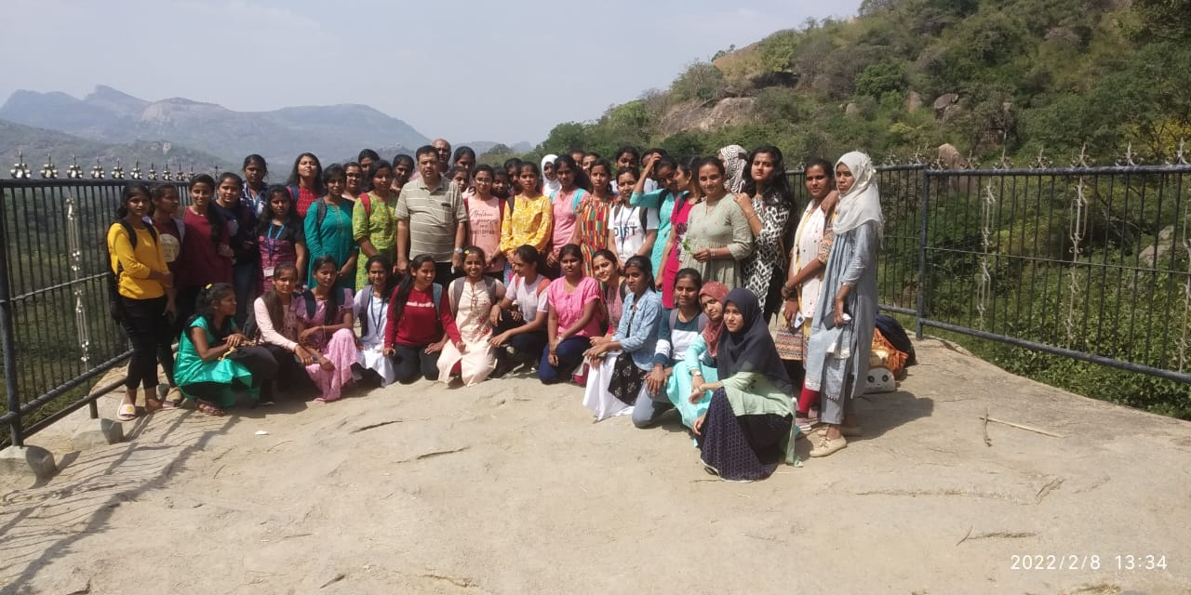

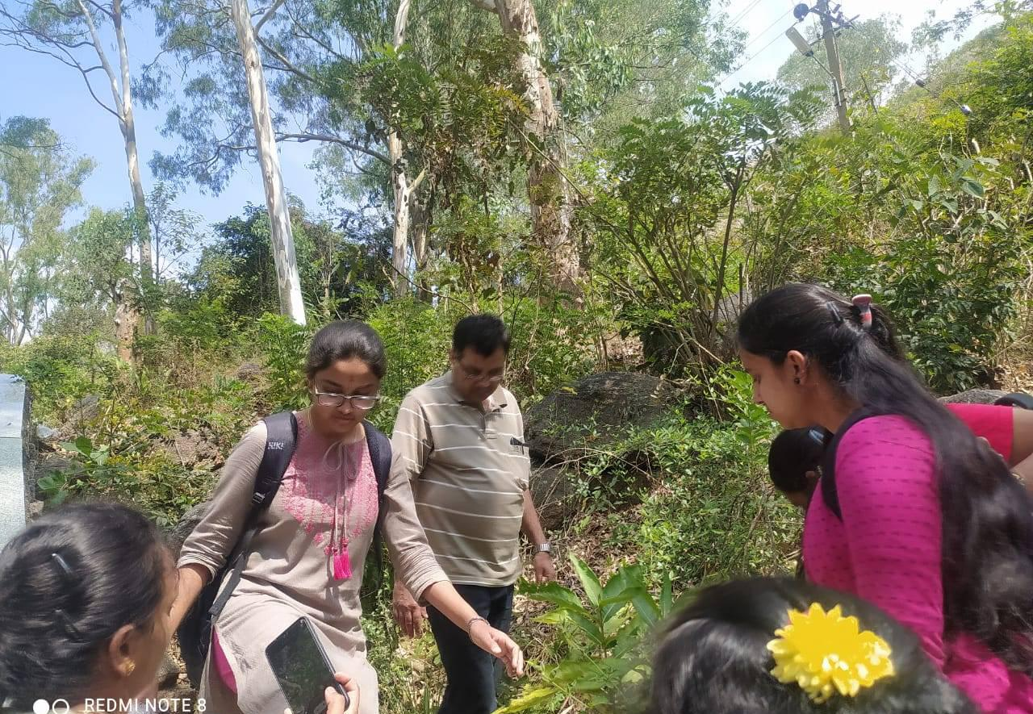

Devarayanadurga forest visit for plant taxonomical studies

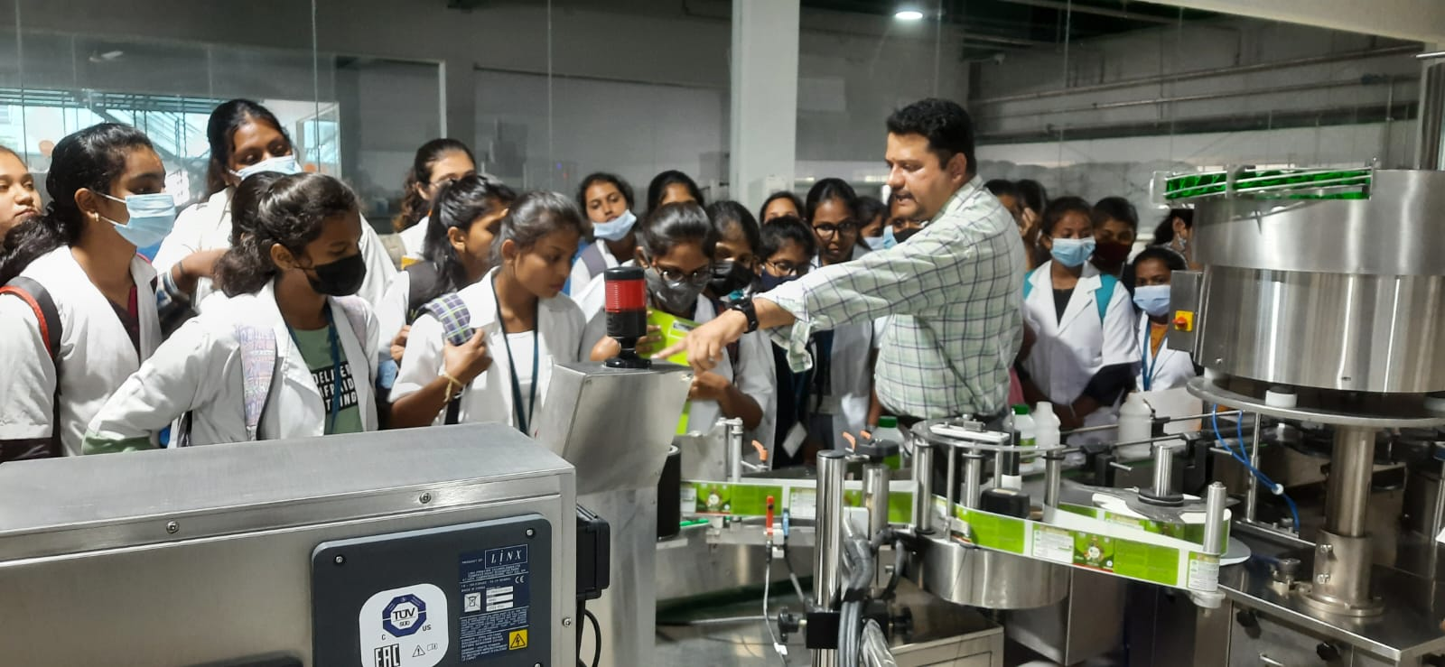
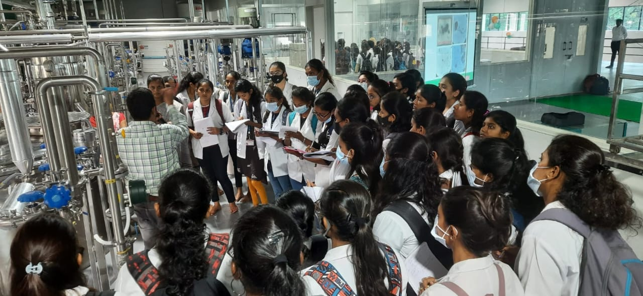
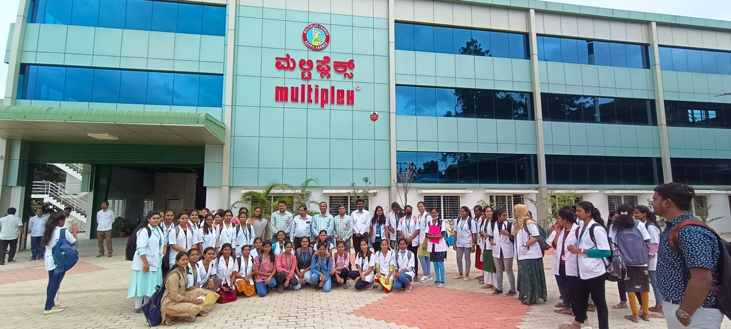
Multiplex Pvt Ltd.,

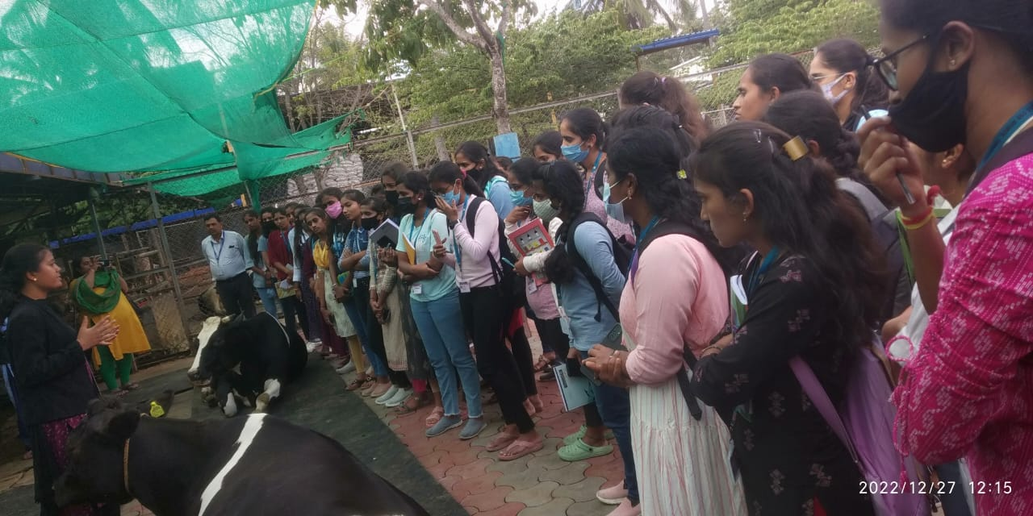

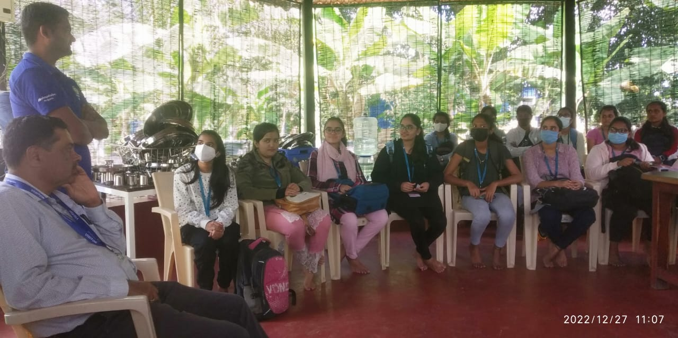

Akshayakalpa organic farm visit on 27/12/2022

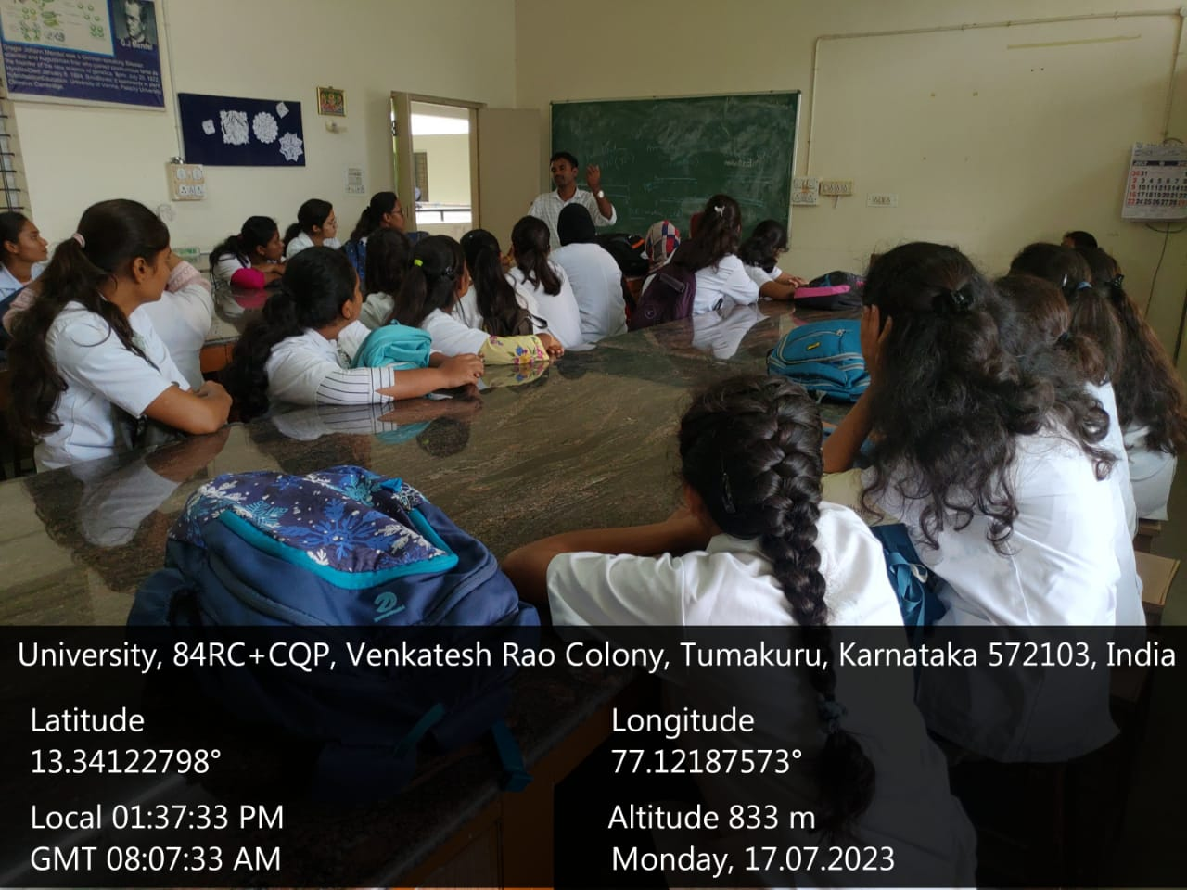
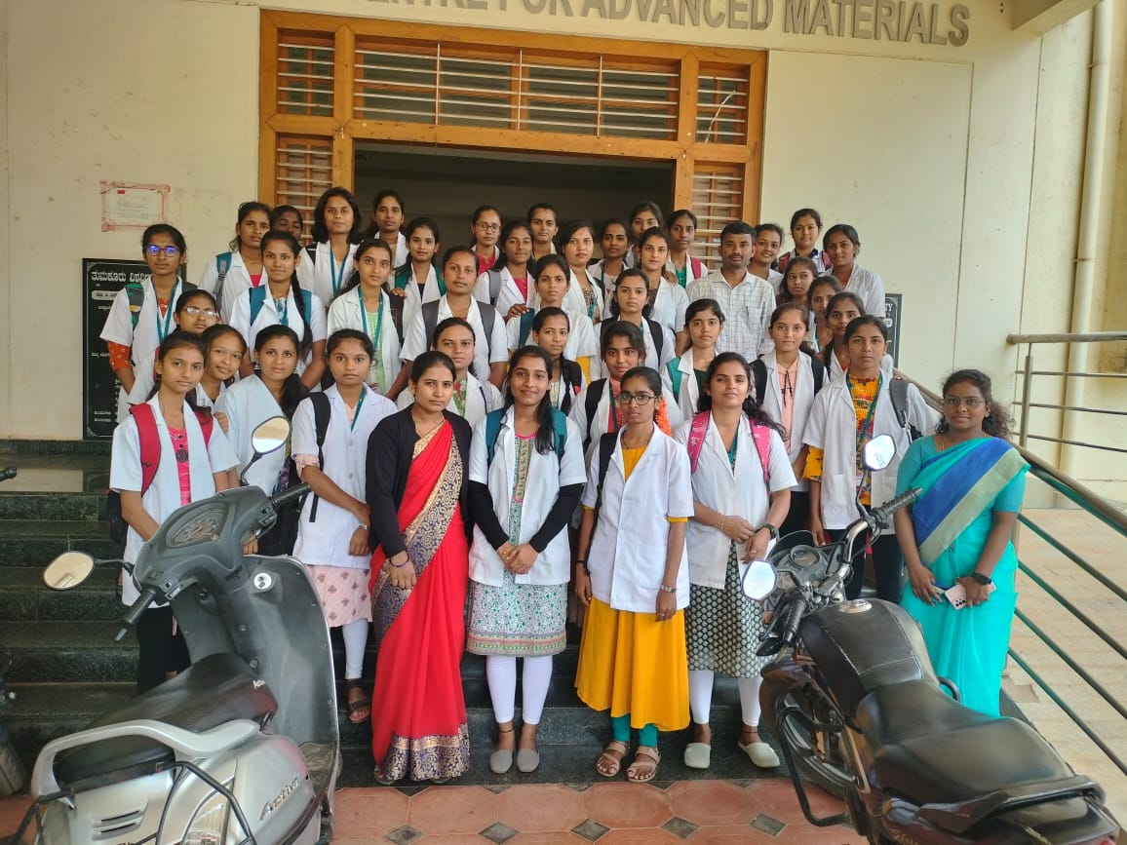

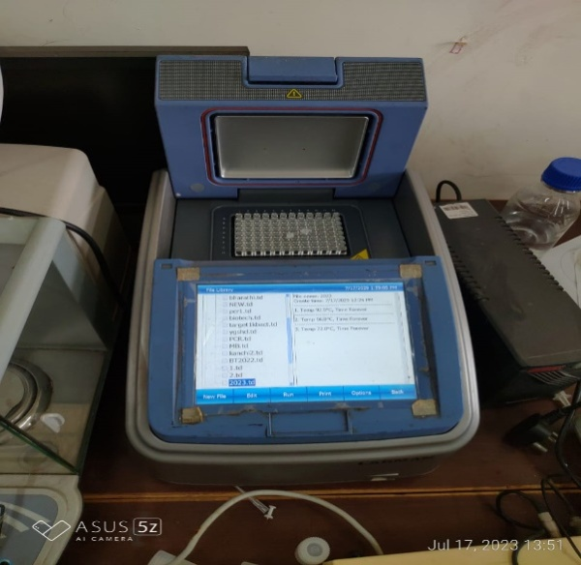
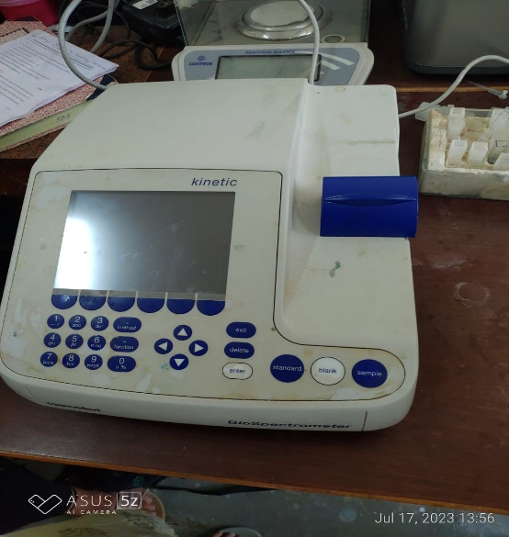

Tumkur University lab visit

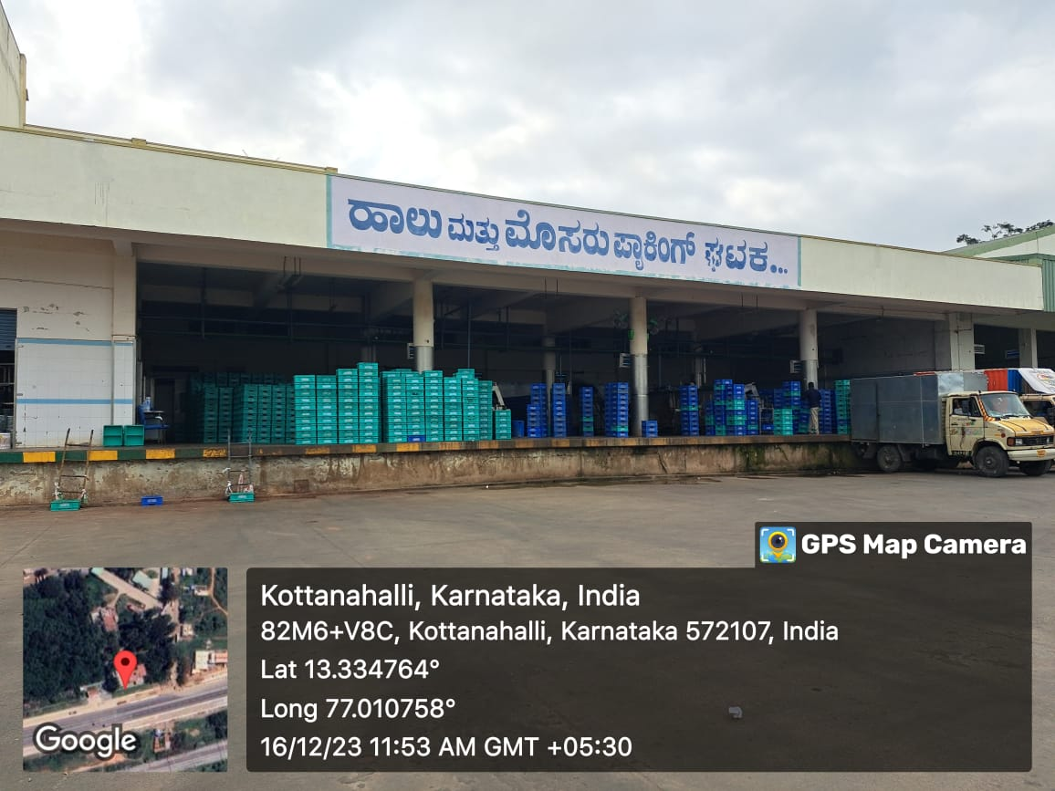
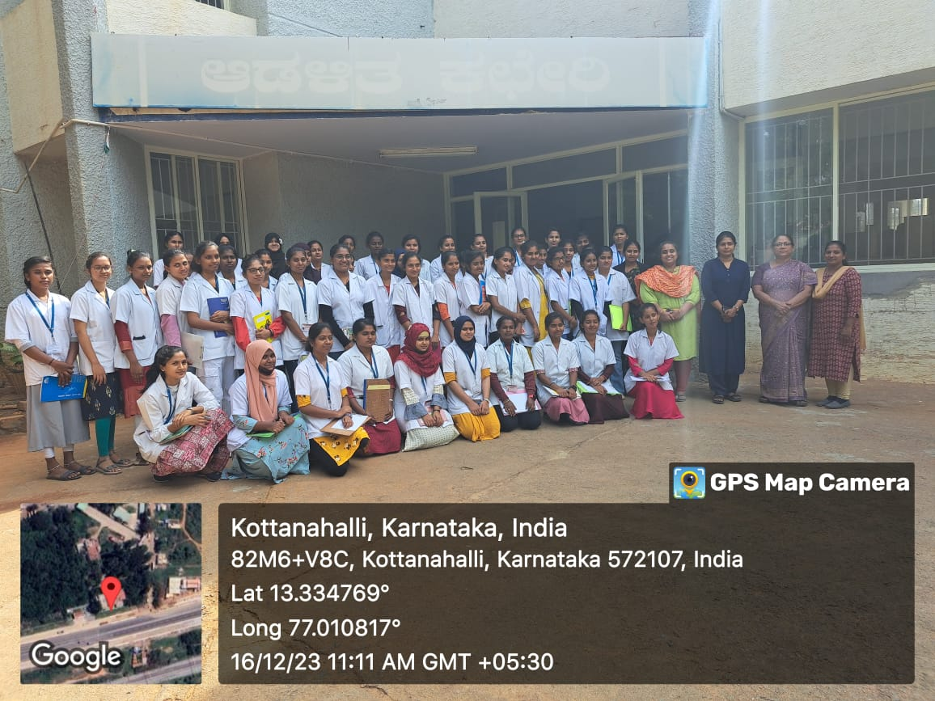

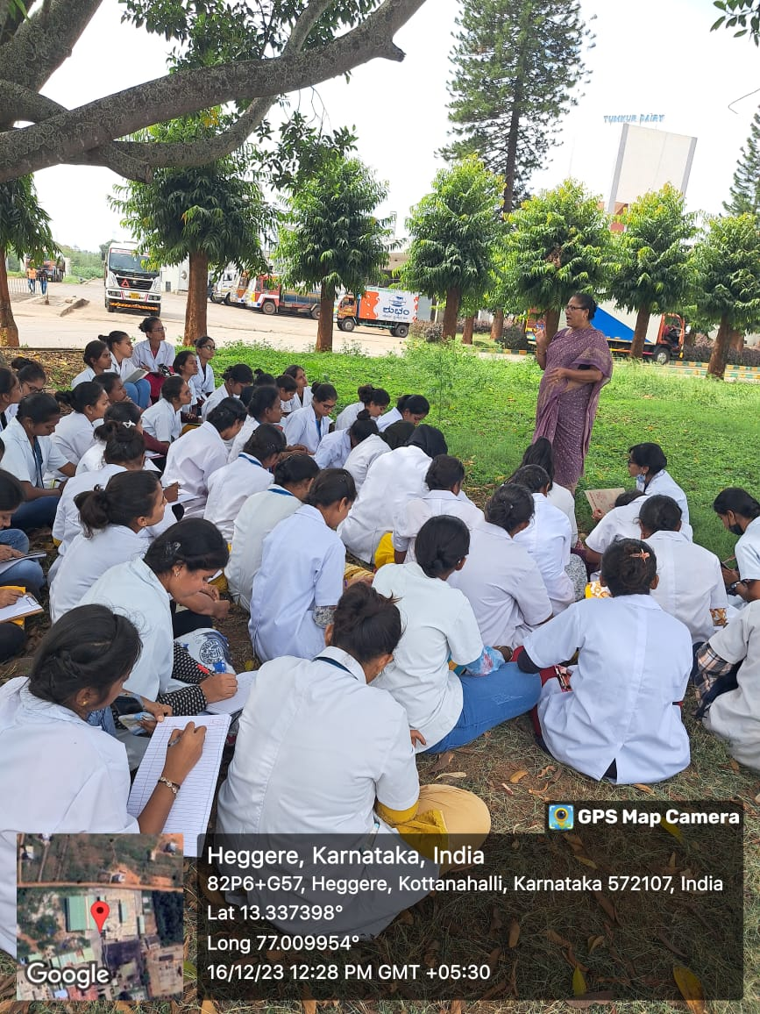
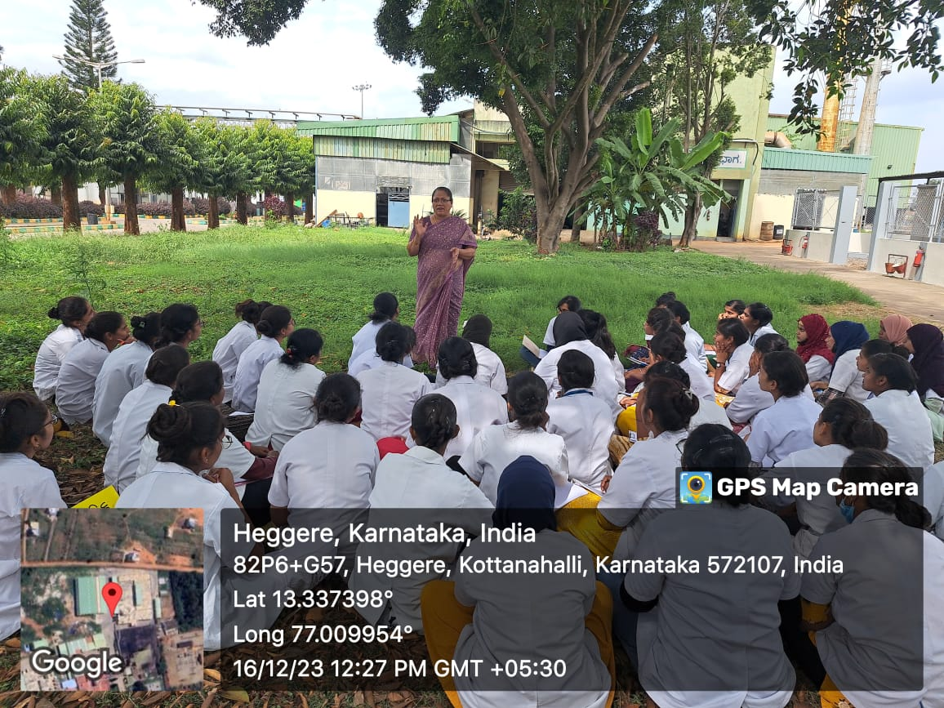

KMF Dairy visit

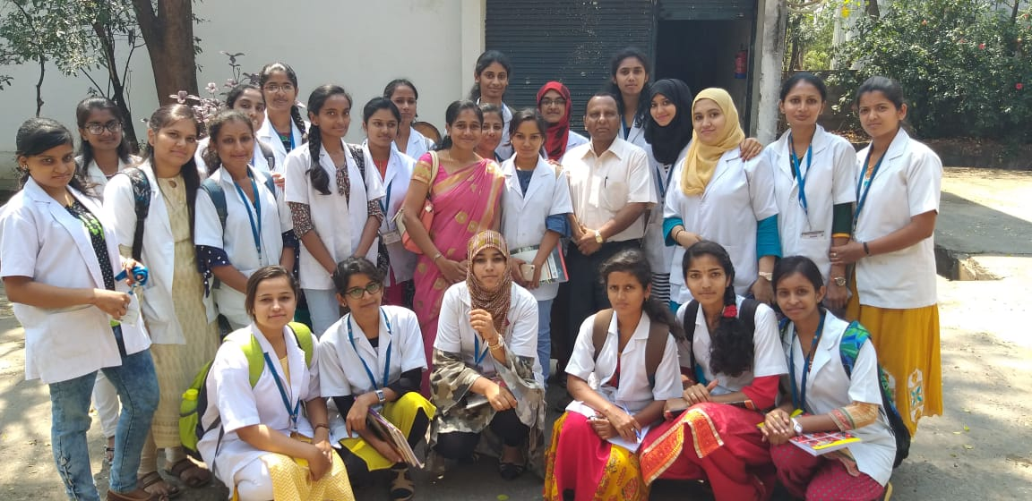
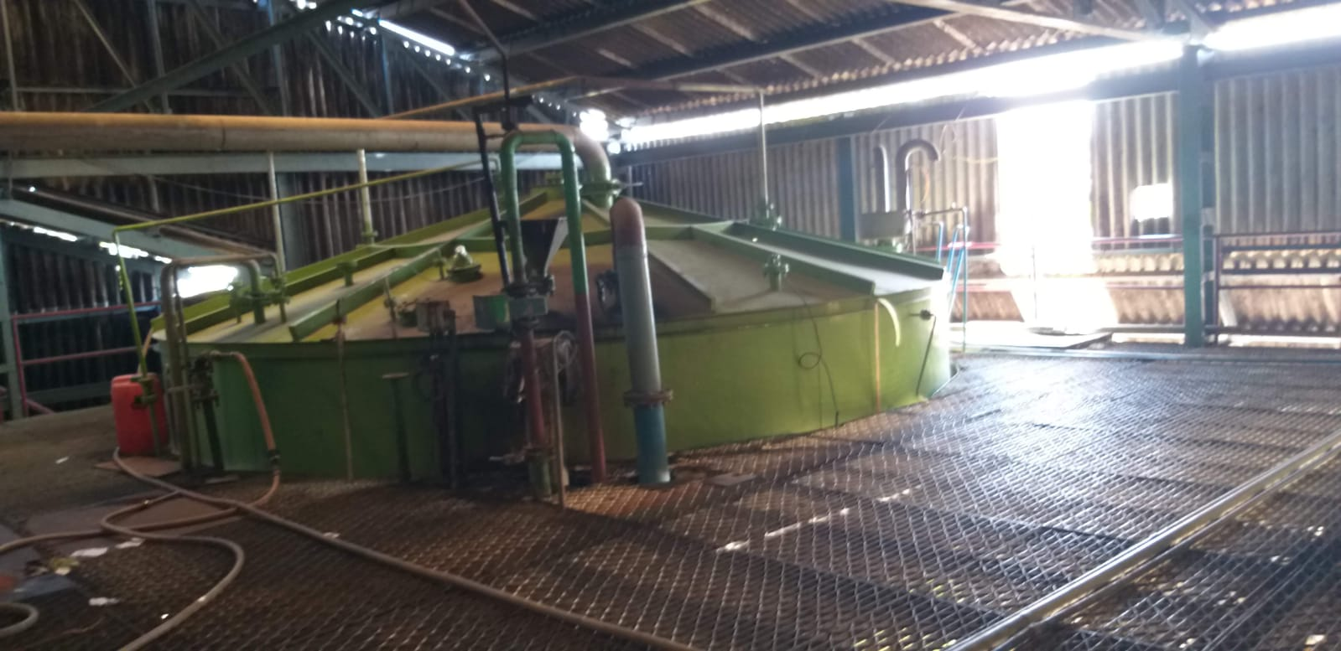

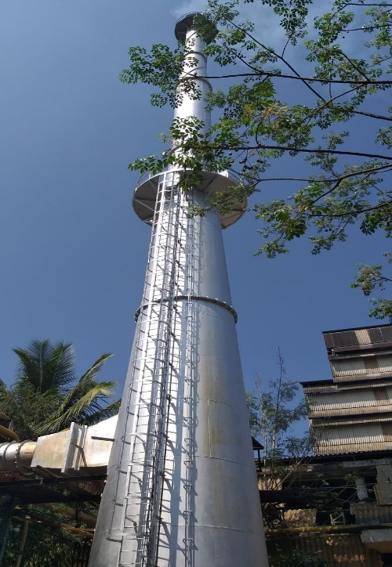
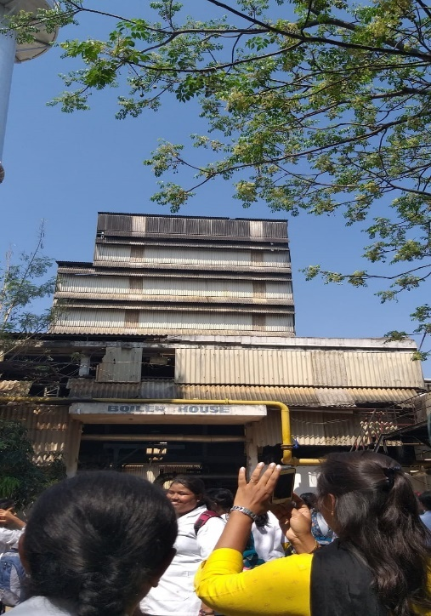

J.P Distilleries Pvt. Ltd.,

DEPARTMENT OF BOTANY
RESULT ANALYSIS
2018 TO 2023

YEAR | SEM | PAPER | NO. APPEARED | DISTINCTION | FIRST CLASS | SECOND CLASS | PASS | FAIL | TOTAL PASS | PERCENTAGE
2018-2019 | ODD | PAPER-V | 84 | 13 | 55 | 03 | - | 06 | 78 | 92.85
 |  | PAPER-VI | 84 | 01 | 71 | 08 | - | 04 | 80 | 95.23
 | EVEN | PAPER-VII | 84 | 23 | 47 | 05 | - | 07 AB-2 | 75 | 89.28
 |  | PAPER-VIII | 84 | 10 | 52 | 07 | 01 | 12 | 72 | 85.71
2019-2020 | ODD | PAPER-V | 83 | 32 | 37 | 10 | 04 |  | 83 | 100
 |  | PAPER-VI | 83 | 44 | 23 | 13 | 02 |  | 83 | 100
 | EVEN | PAPER-VII | 83 | 18 | 49 | 10 | - | 06 | 77 | 92.77
 |  | PAPER-VIII | 83 | 18 | 53 | 7 | - | 05 | 78 | 91.56
2020-2021 | ODD | PAPER-V | 88 | 08 | 59 | 10 | - | 10 | 78 | 88.63
 |  | PAPER-VI | 88 | 22 | 55 | 10 | - | 01 | 87 | 98.83
 | EVEN | PAPER-VII | 88 | 08 | 59 | 10 | - | 11 | 77 | 87.5
 |  | PAPER-VIII | 88 | 22 | 55 | 10 | - | 01 | 87 | 98.86
2021-2022 | ODD | PAPER-V | 86 | 47 | 32 | 03 | - | 02 | 84 | 97.67
 |  | PAPER-VI | 86 | 42 | 39 | 01 | - | 02 | 84 | 97.67
 | EVEN | PAPER-VII | 85 | 43 | 37 | 02 | - | 03 | 82 | 96.47
 |  | PAPER-VIII | 85 | 41 | 35 | 02 | - | 07 | 78 | 91.76
2022-2023 | ODD | PAPER-V | 92 | 42 | 46 | 04 | - | 00 | 92 | 100
 |  | PAPER-VI | 92 | 57 | 34 | - | - | 01 | 91 | 98.91
 | EVEN | PAPER-VII | 92 | 30 | 43 | 13 | - | 06 | 86 | 93.47
 |  | PAPER-VIII | 92 | 48 | 37 | 04 | - | 03 | 89 | 96.73

2018-2019 (ODD SEM AND EVEN SEM)

2019-2020 (ODD AND EVEN SEM)

2020-2021 (ODD AND EVEN SEM)

2021-2022 (ODD AND EVEN SEM)

2022-2023 (ODD AND EVEN SEM)

DEPARTMENT OF BOTANY
LIST OF RANK HOLDERS
SL.NO | NAME | COMBINATION | YEAR | RANK
1. | LAVANYA M.K | CBBt | 2018-19 | 9th
2. | POORNIMA K | CBZ | 2019-20 | GOLD MEDALIST
3. | MOULIKA V.S | CBZ | 2019-20 | 3rd
4. | SUMA R.N | CBZ | 2019-20 | 5th
5. | RANISHREE S.R | CBZ | 2020-21 | 1st
6. | NEHA S | CBZ | 2020-21 | 3rd
7. | RACHANA REDDY S | CBZ | 2020-21 | 10th

2018-2019
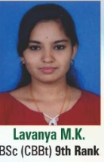

2019-2020

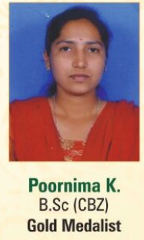
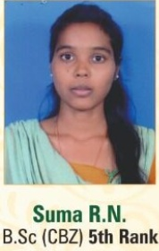
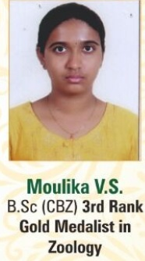

2020-2021

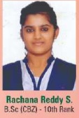
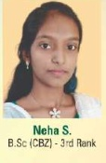


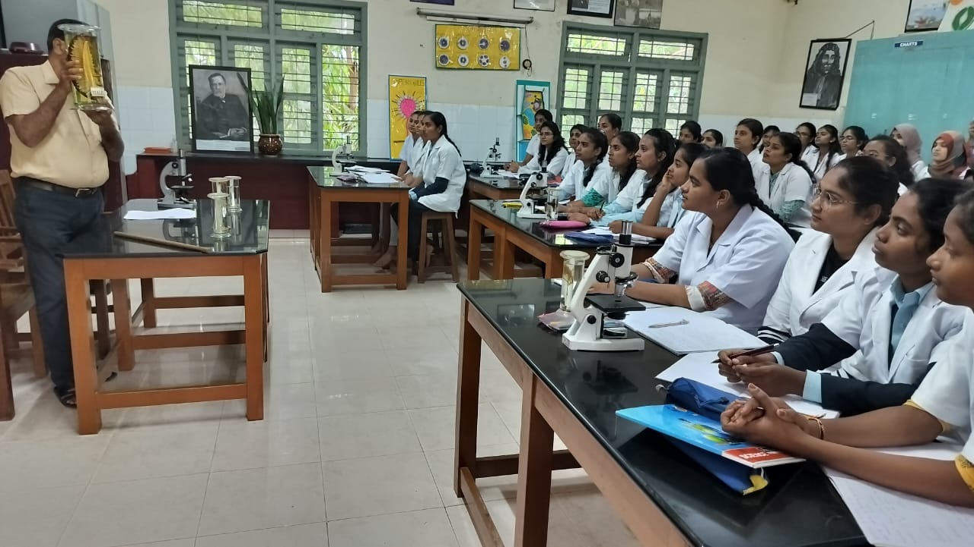
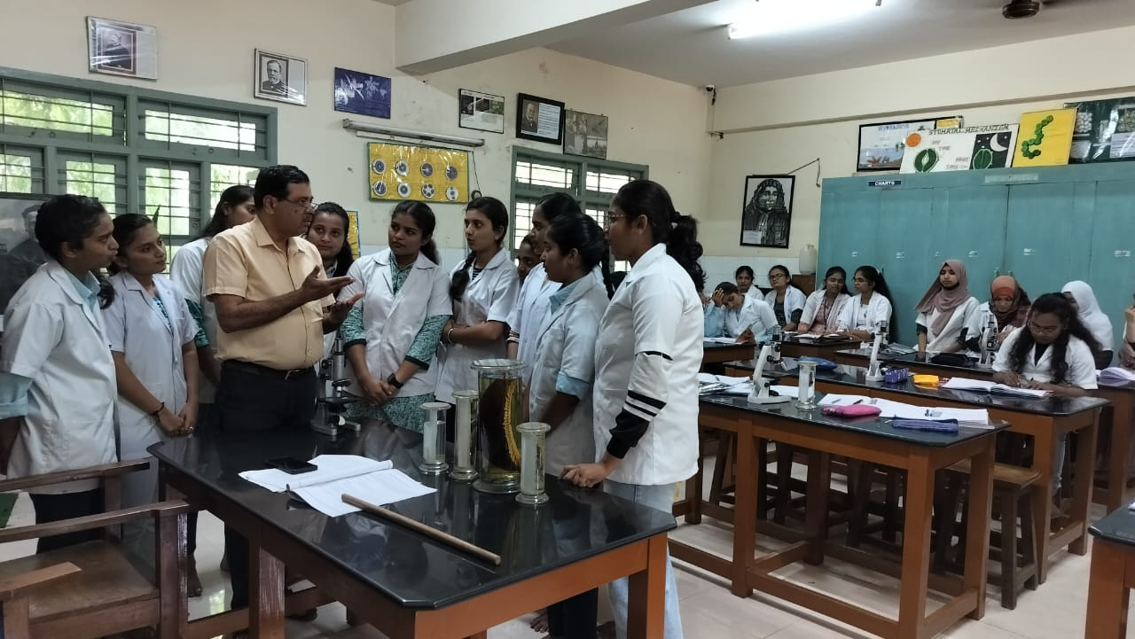

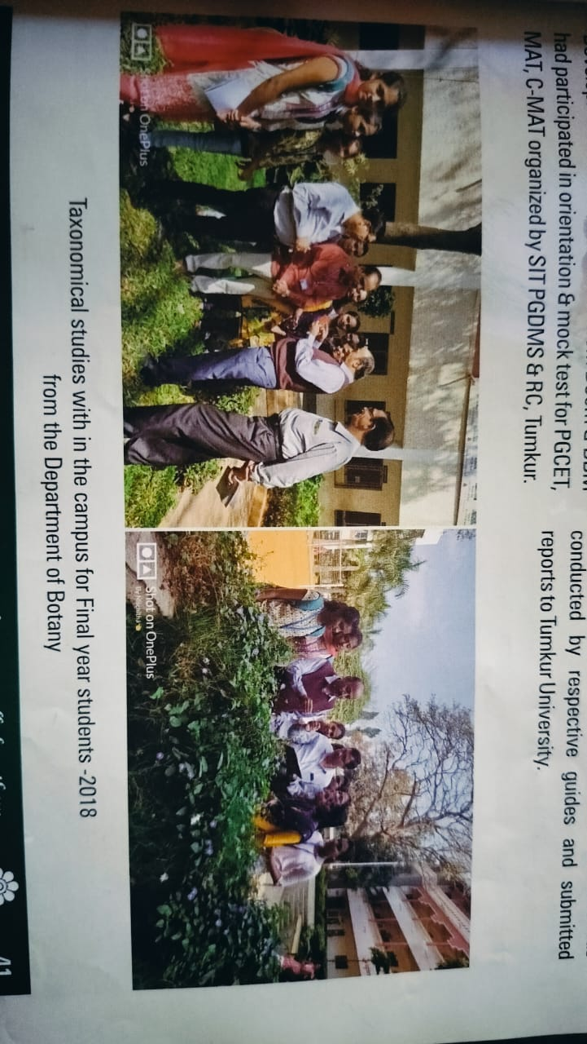
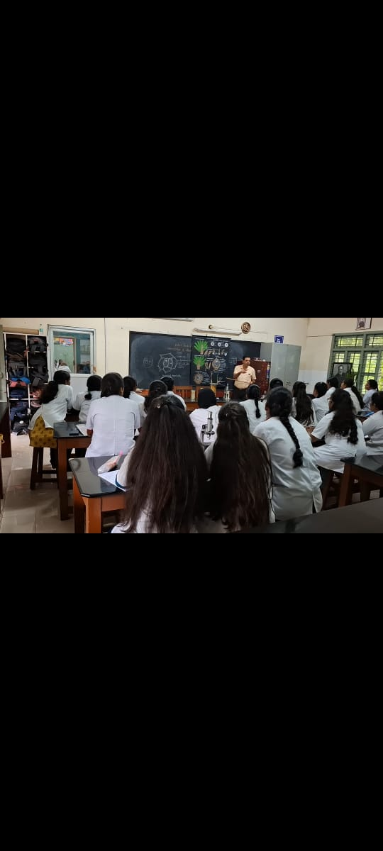

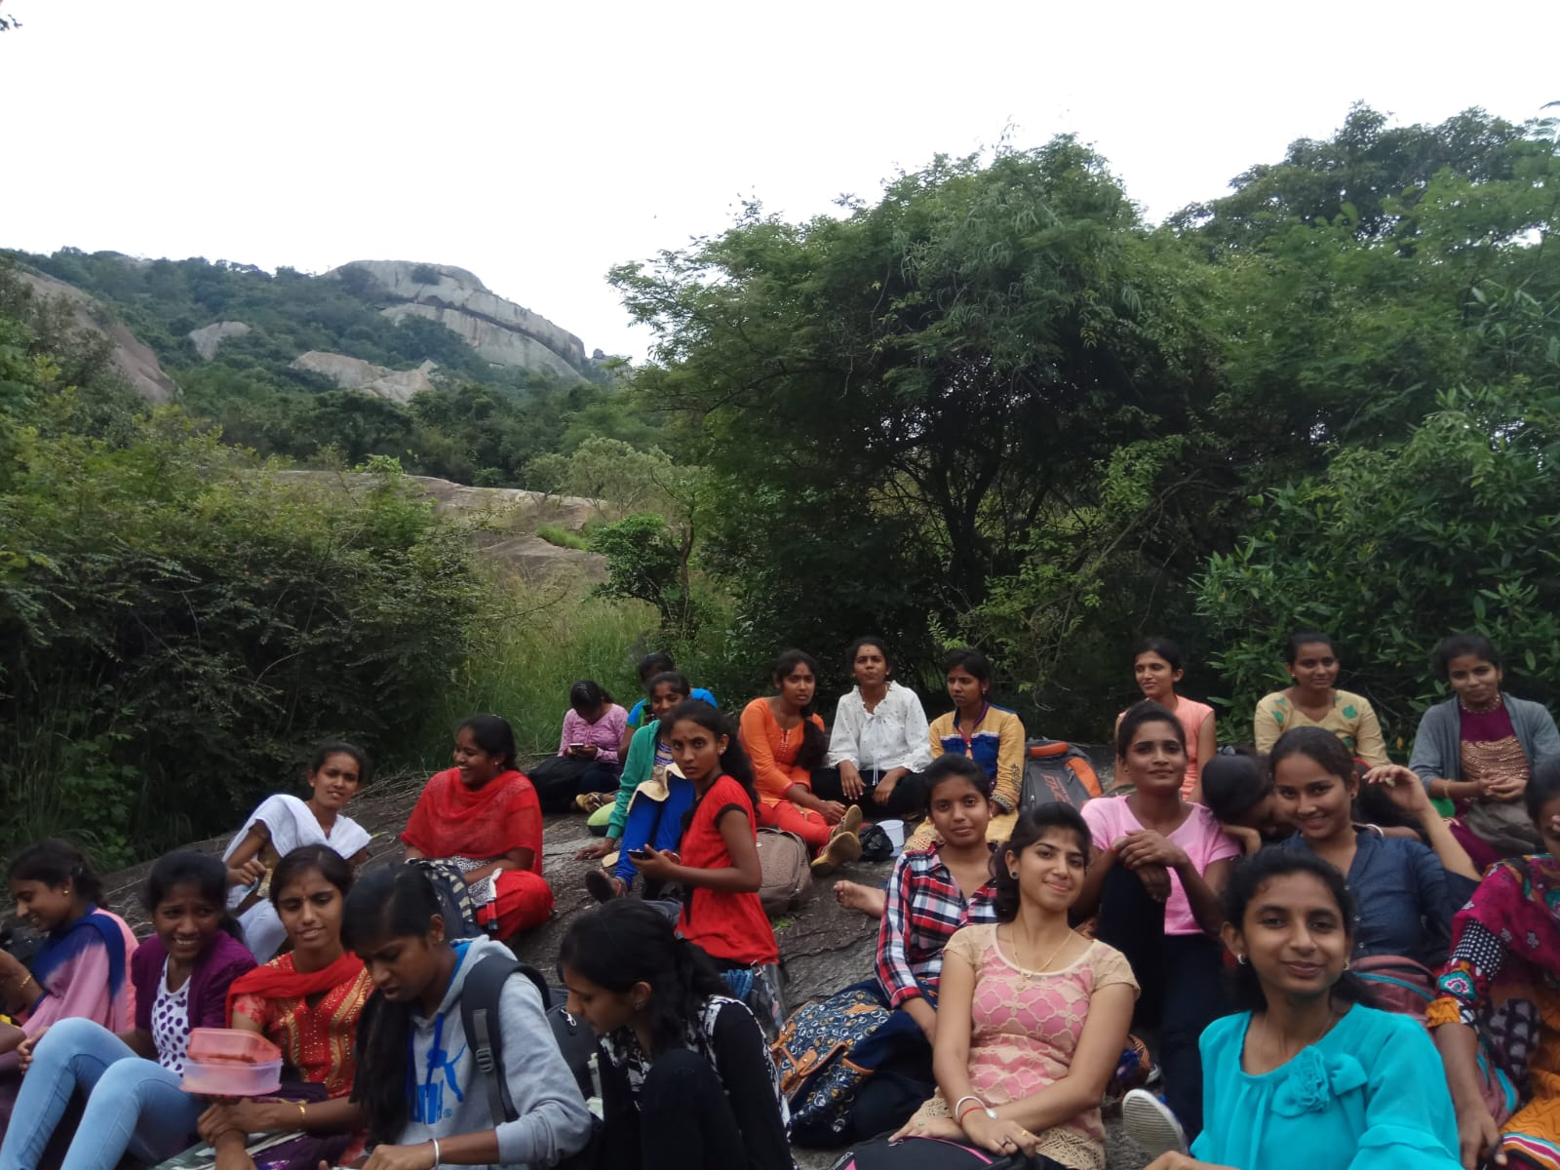
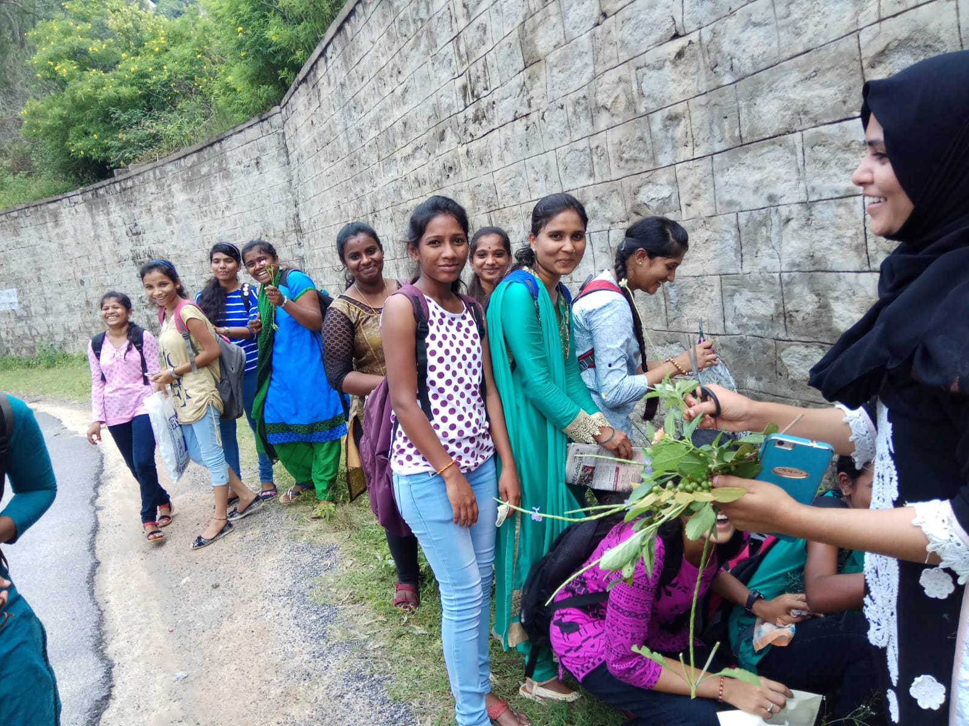

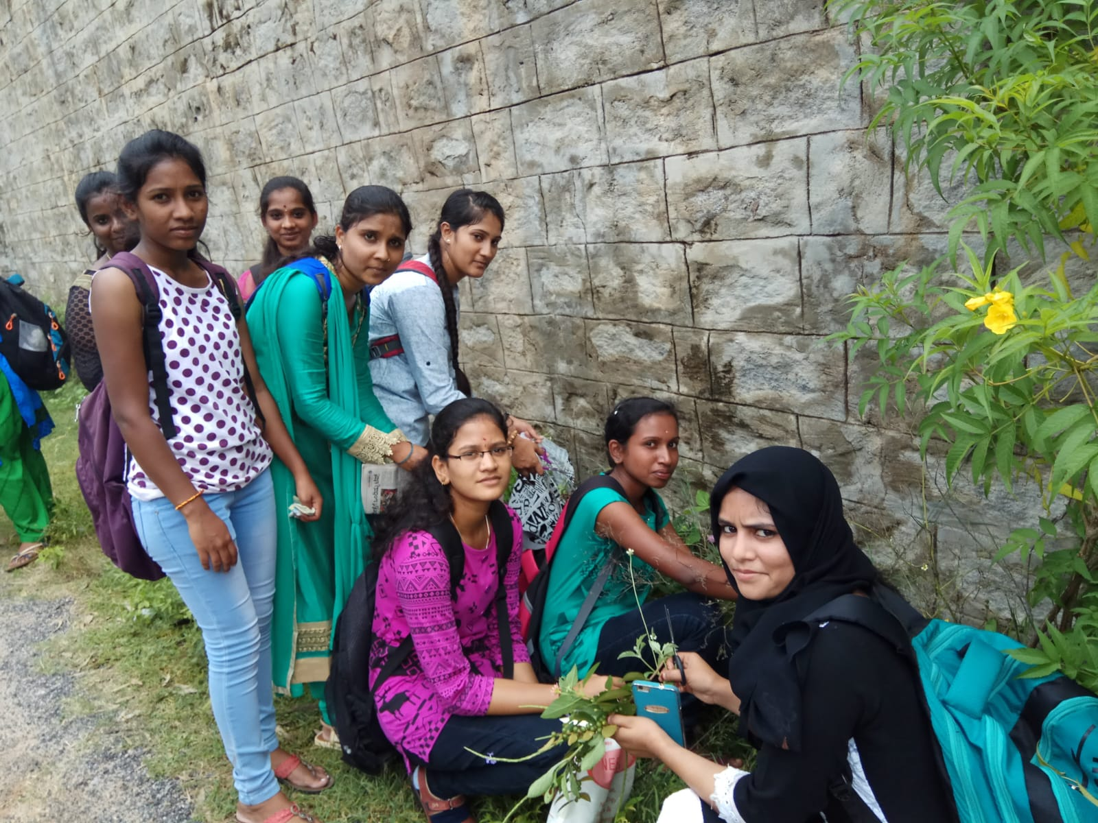

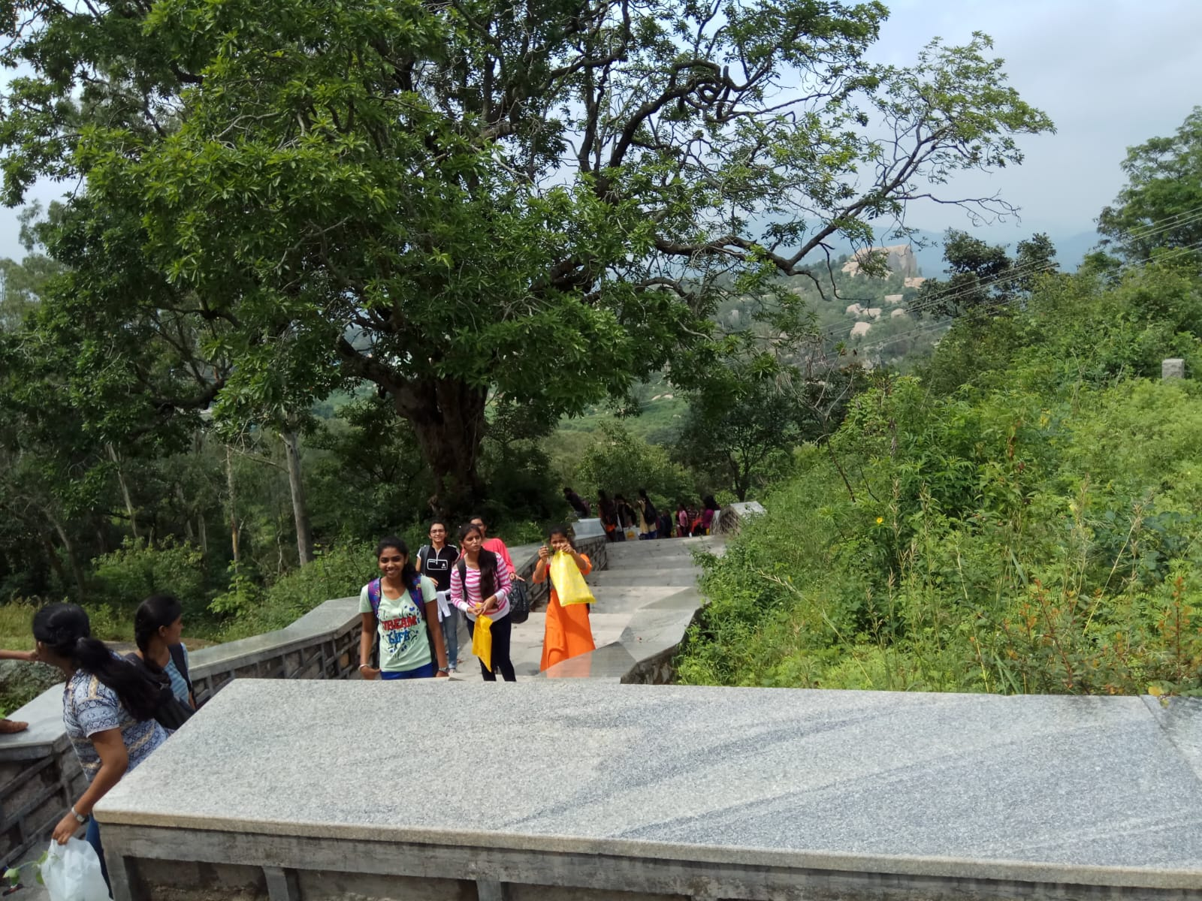

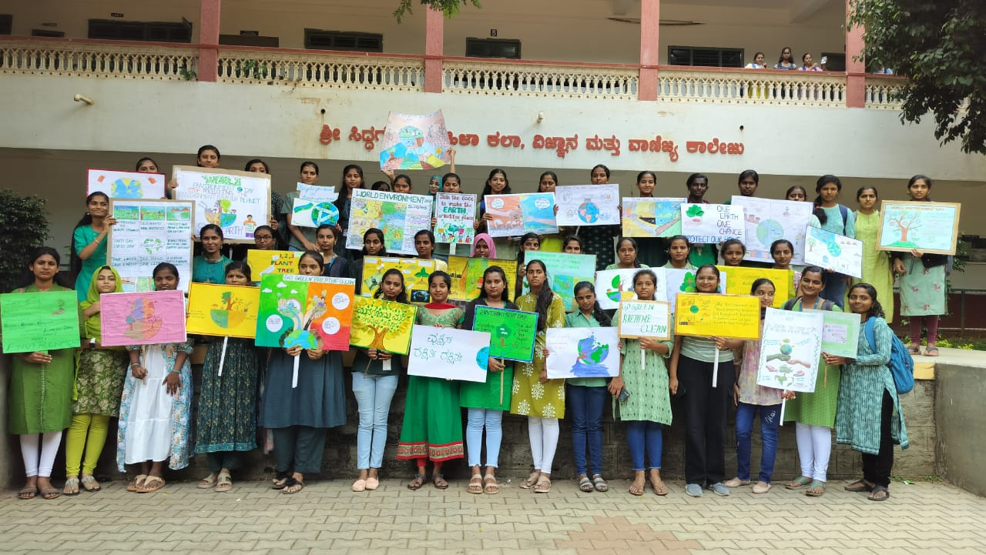

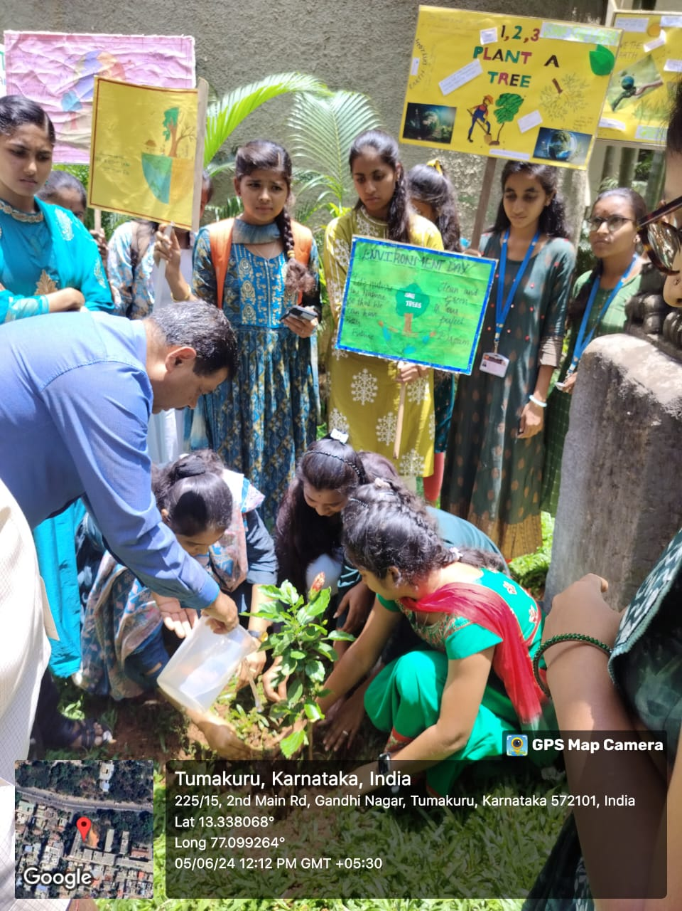

Students seminars
