SREE SIDDAGANGA COLLEGE OF ARTS SCIENCE AND COMMERCE FOR WOMEN, TUMKUR.
WOMEN EMPOWERMENT CELL 2019-2020
23-01-2020

The Women empowerment cell of Sree Siddaganga College of Arts, Science and Commerce has organized a one day workshop on “Organic Farming and Vermi Compost Preparation” on 23-01-2020 at Akkhamahadevi Seminar Hall. The Programme was inaugurated by the Chief guests Mr. Hemanth and Mr. Harshith by watering the pot. Both the chief guests being agricultural consultants in Kotagal Hobli, Ramanagar district gave a demonstration on the importance and practical knowledge of the agriculture, comprehending the organic fertilizers and worm casting as the principle component. The Principal Dr. K C Jayaswamy and IQAC Co-ordinator Prof Madhava, NAAC Co-ordinator Prof G Chidananda Murthy, Dr H.P Veerabadraswamy and members of the women empowerment cell were present on the occasion.
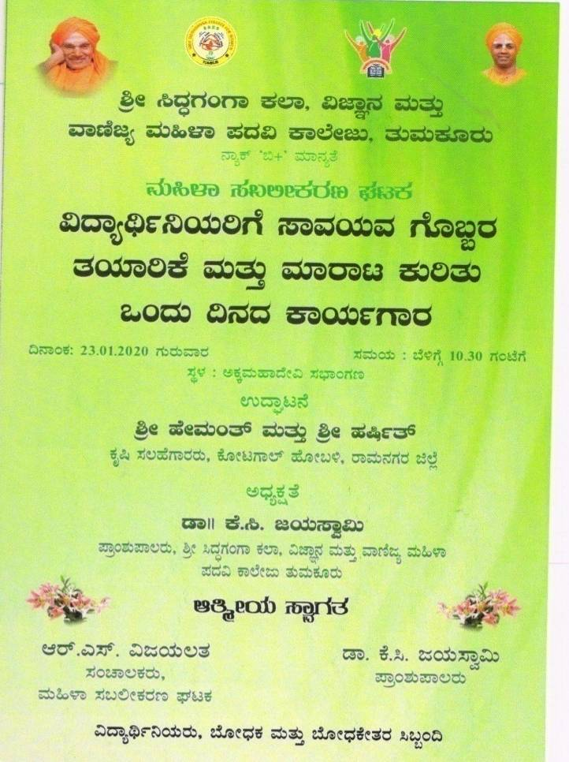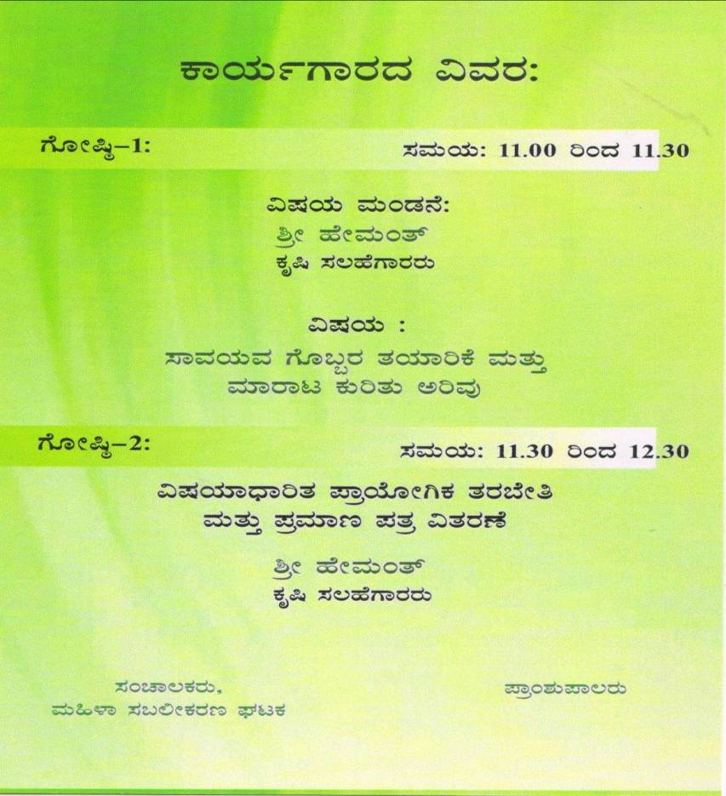

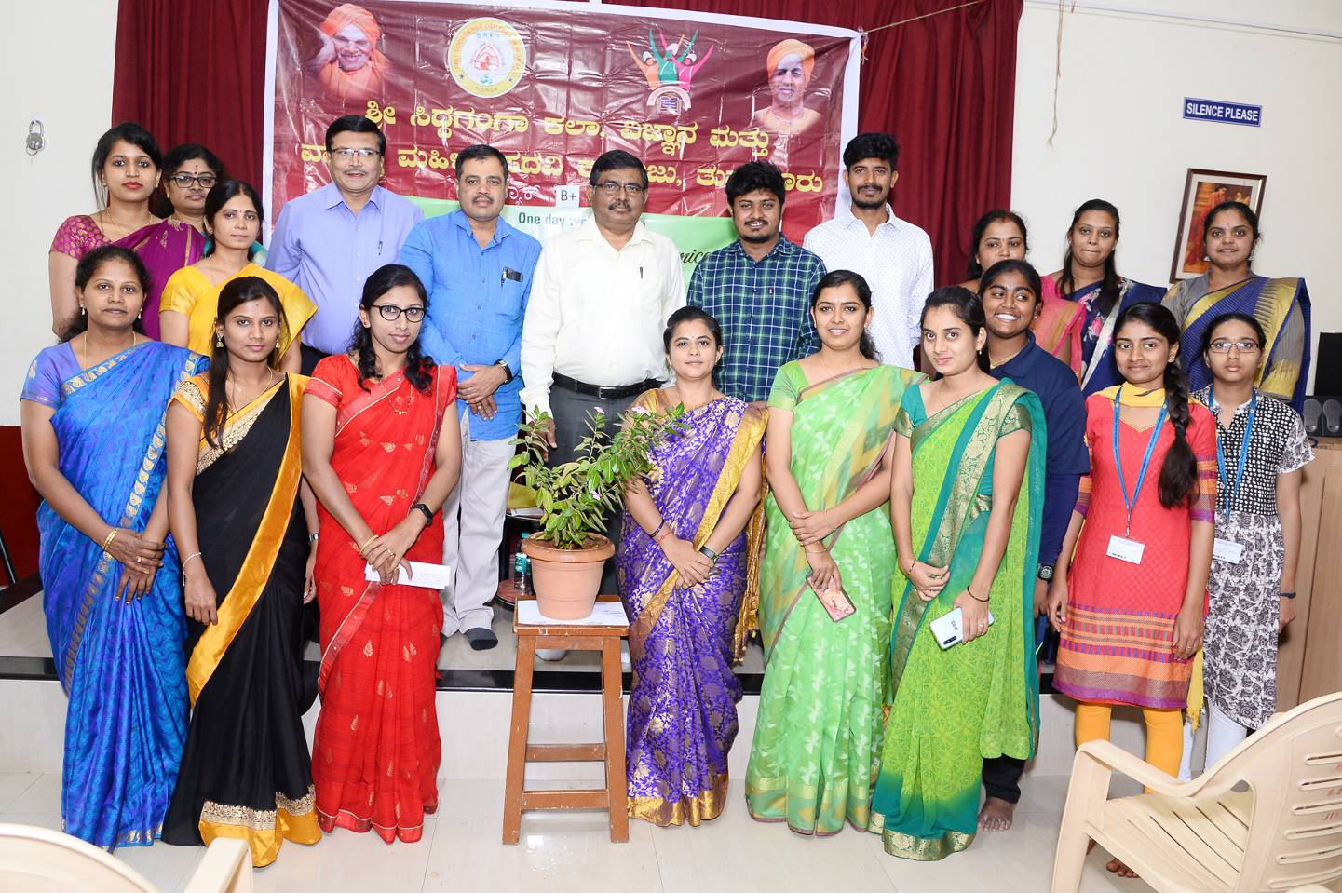
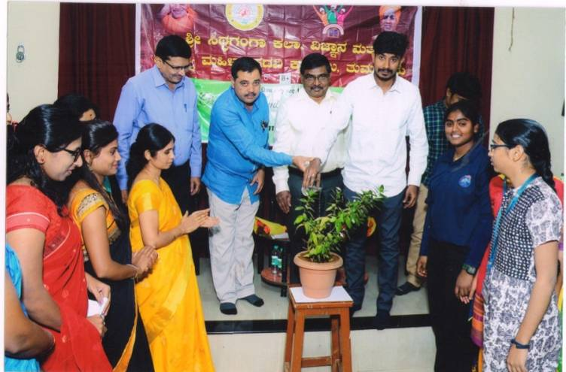
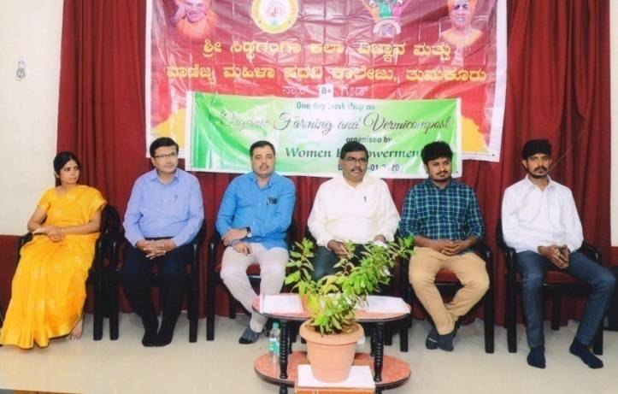
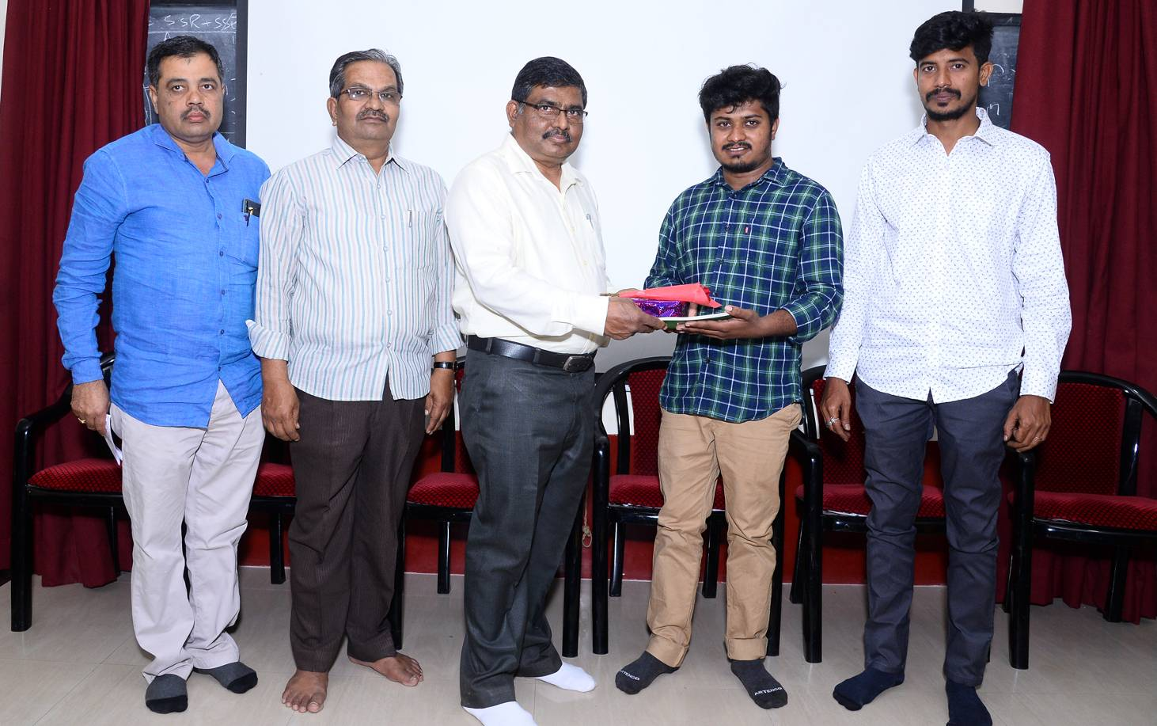
One day workshop on “Organic Forming and Vermi Compost” organized by women empowerment cell


